**Lab 7: Characterization and DC Biasing of the BJT**

**Faizan Bangash**

**Ecen 325-504**

**Date: October 24, 2018**

**Calculations**

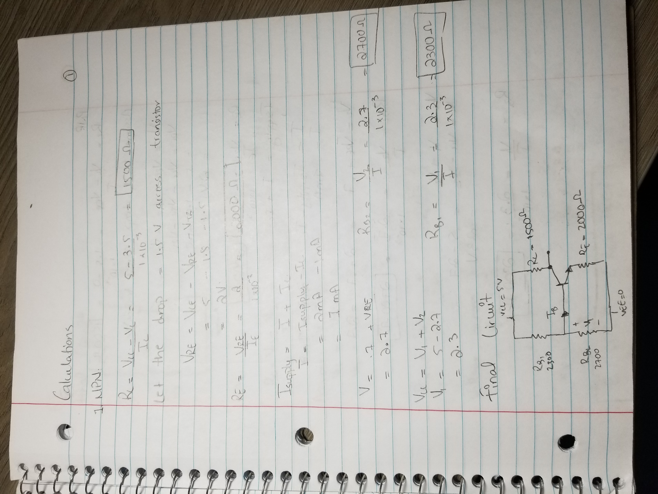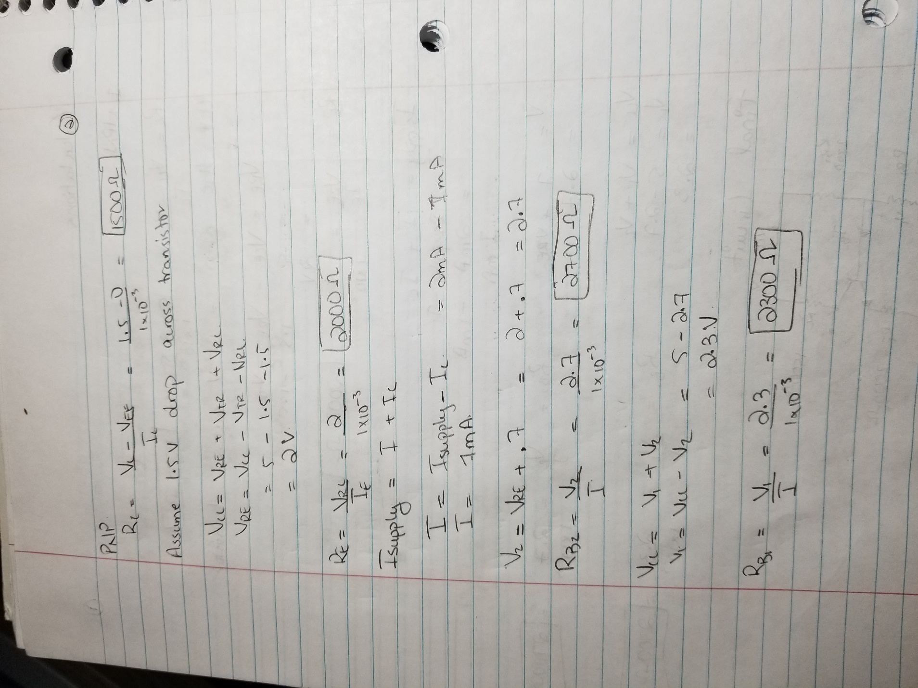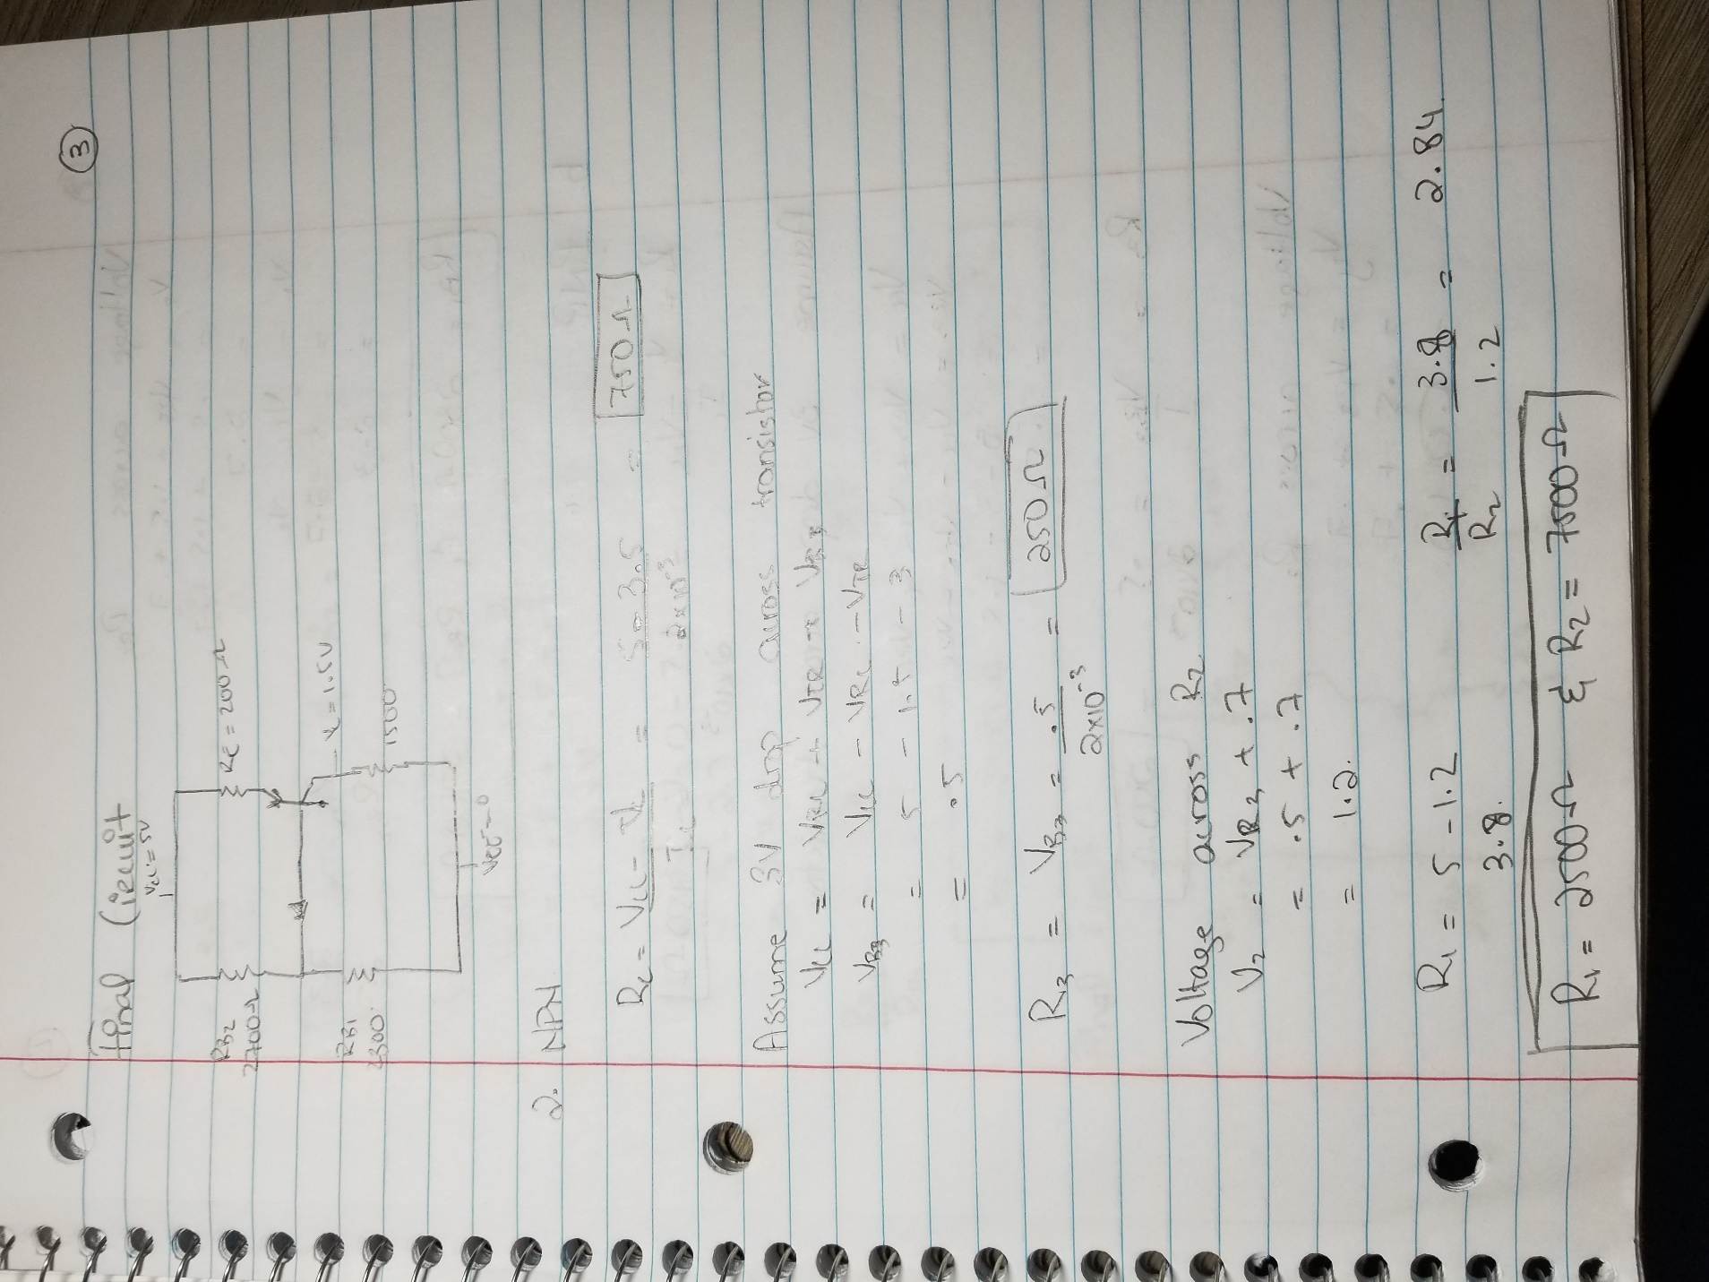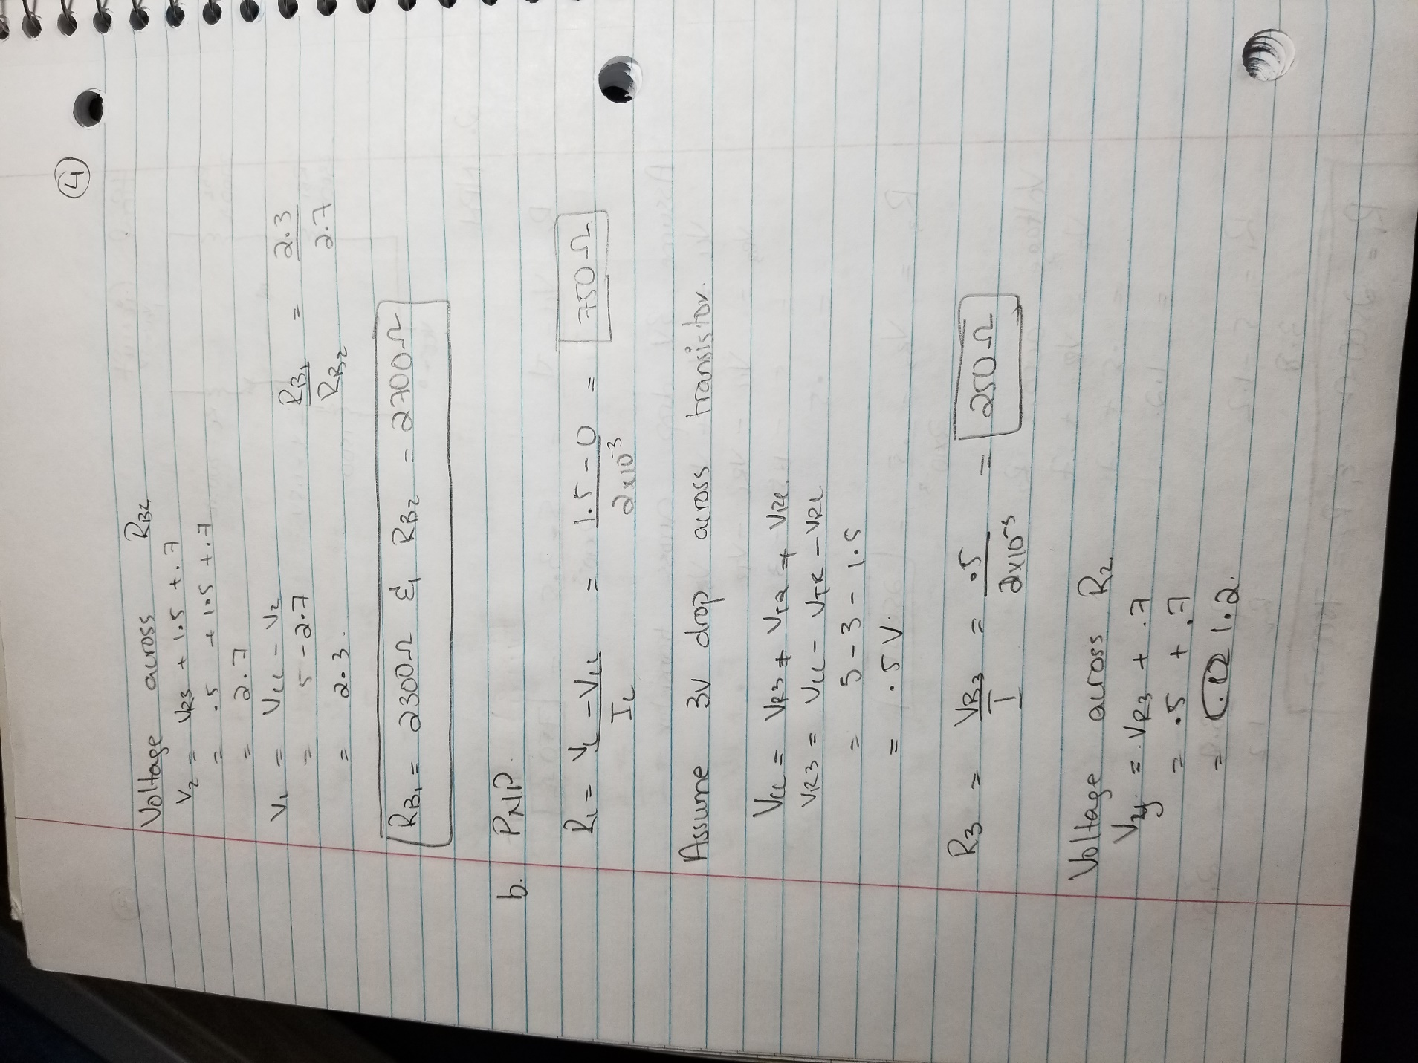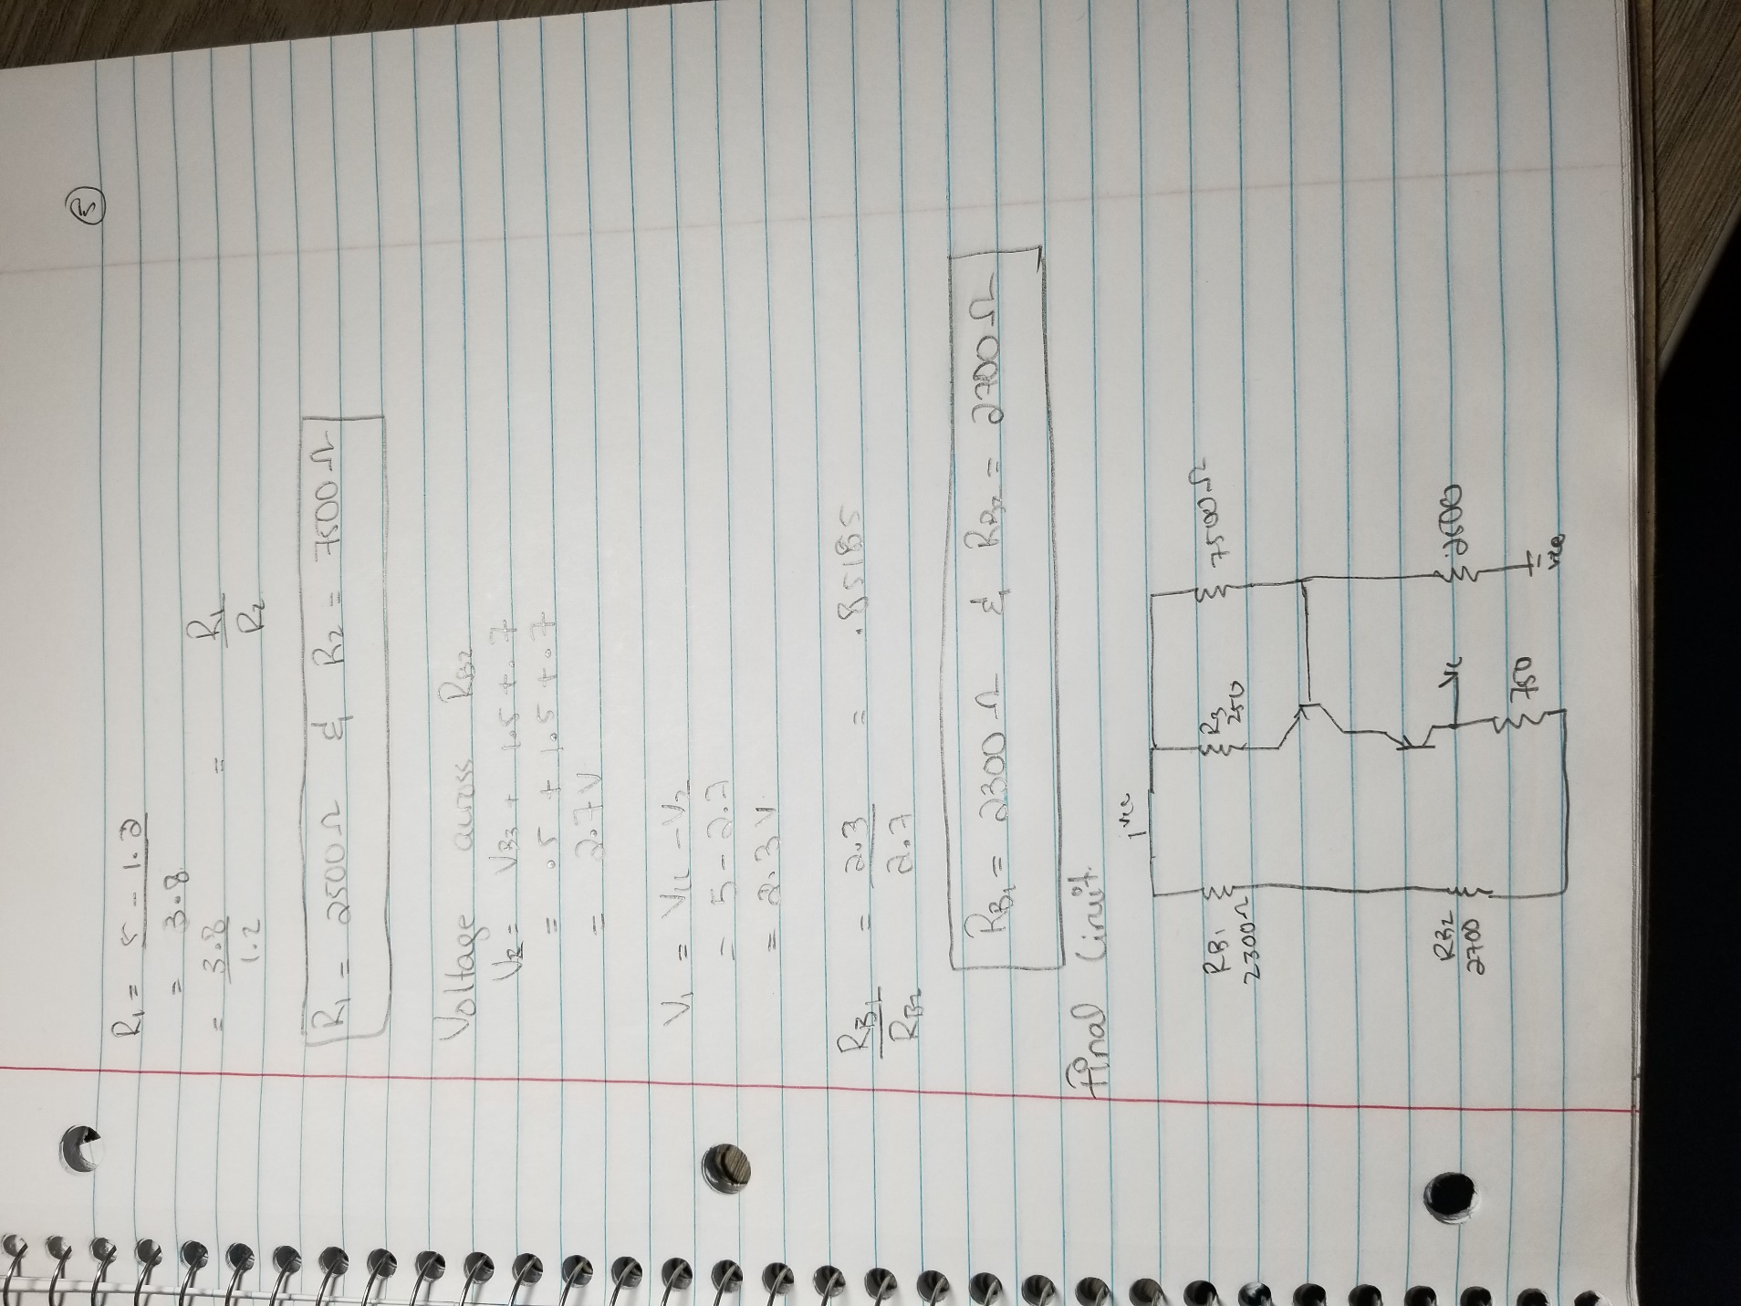

**Simulations**

NPN BJT Characterization circuit

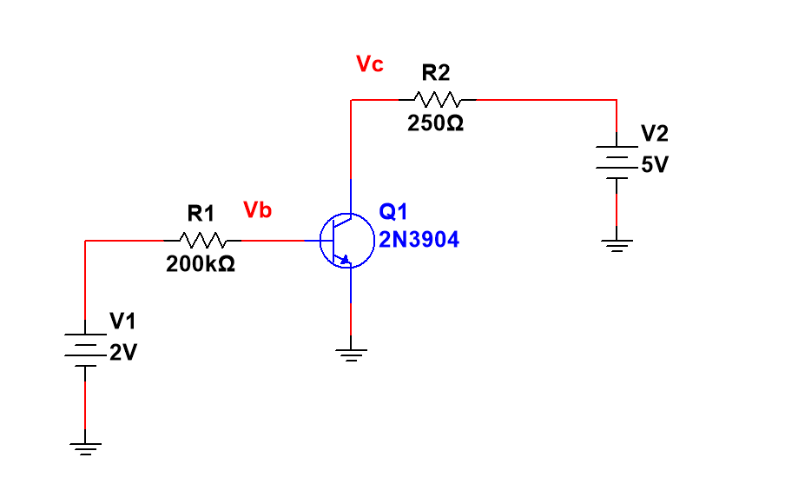

DC sweep Of V1

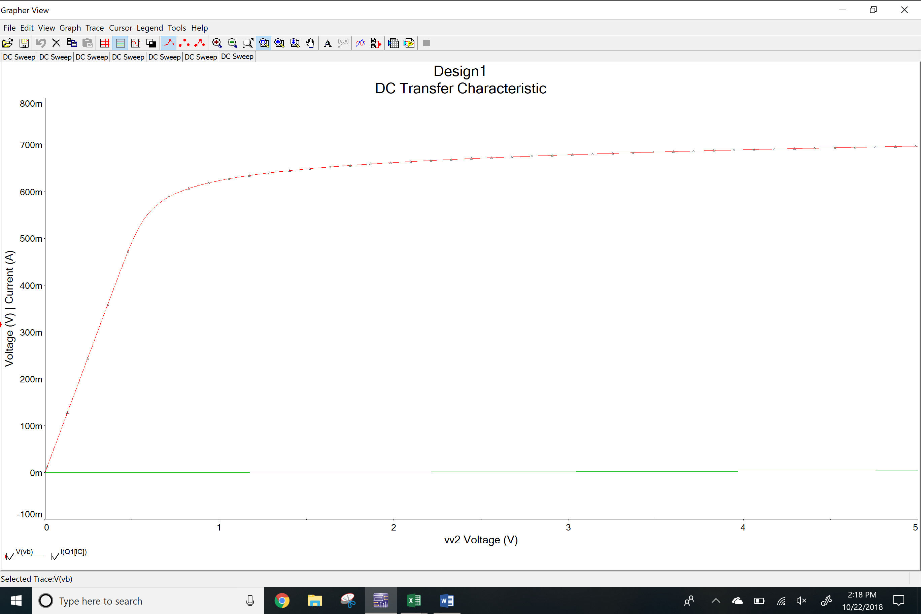

DC sweep of V1 Plot

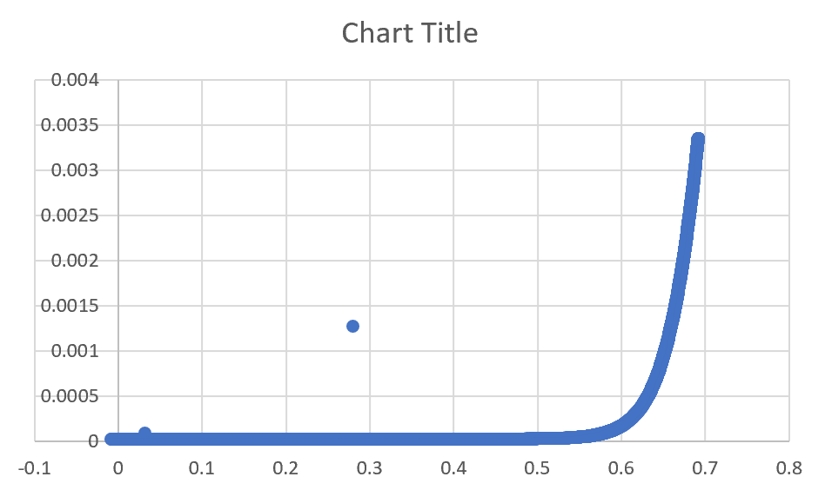

DC sweep of V2

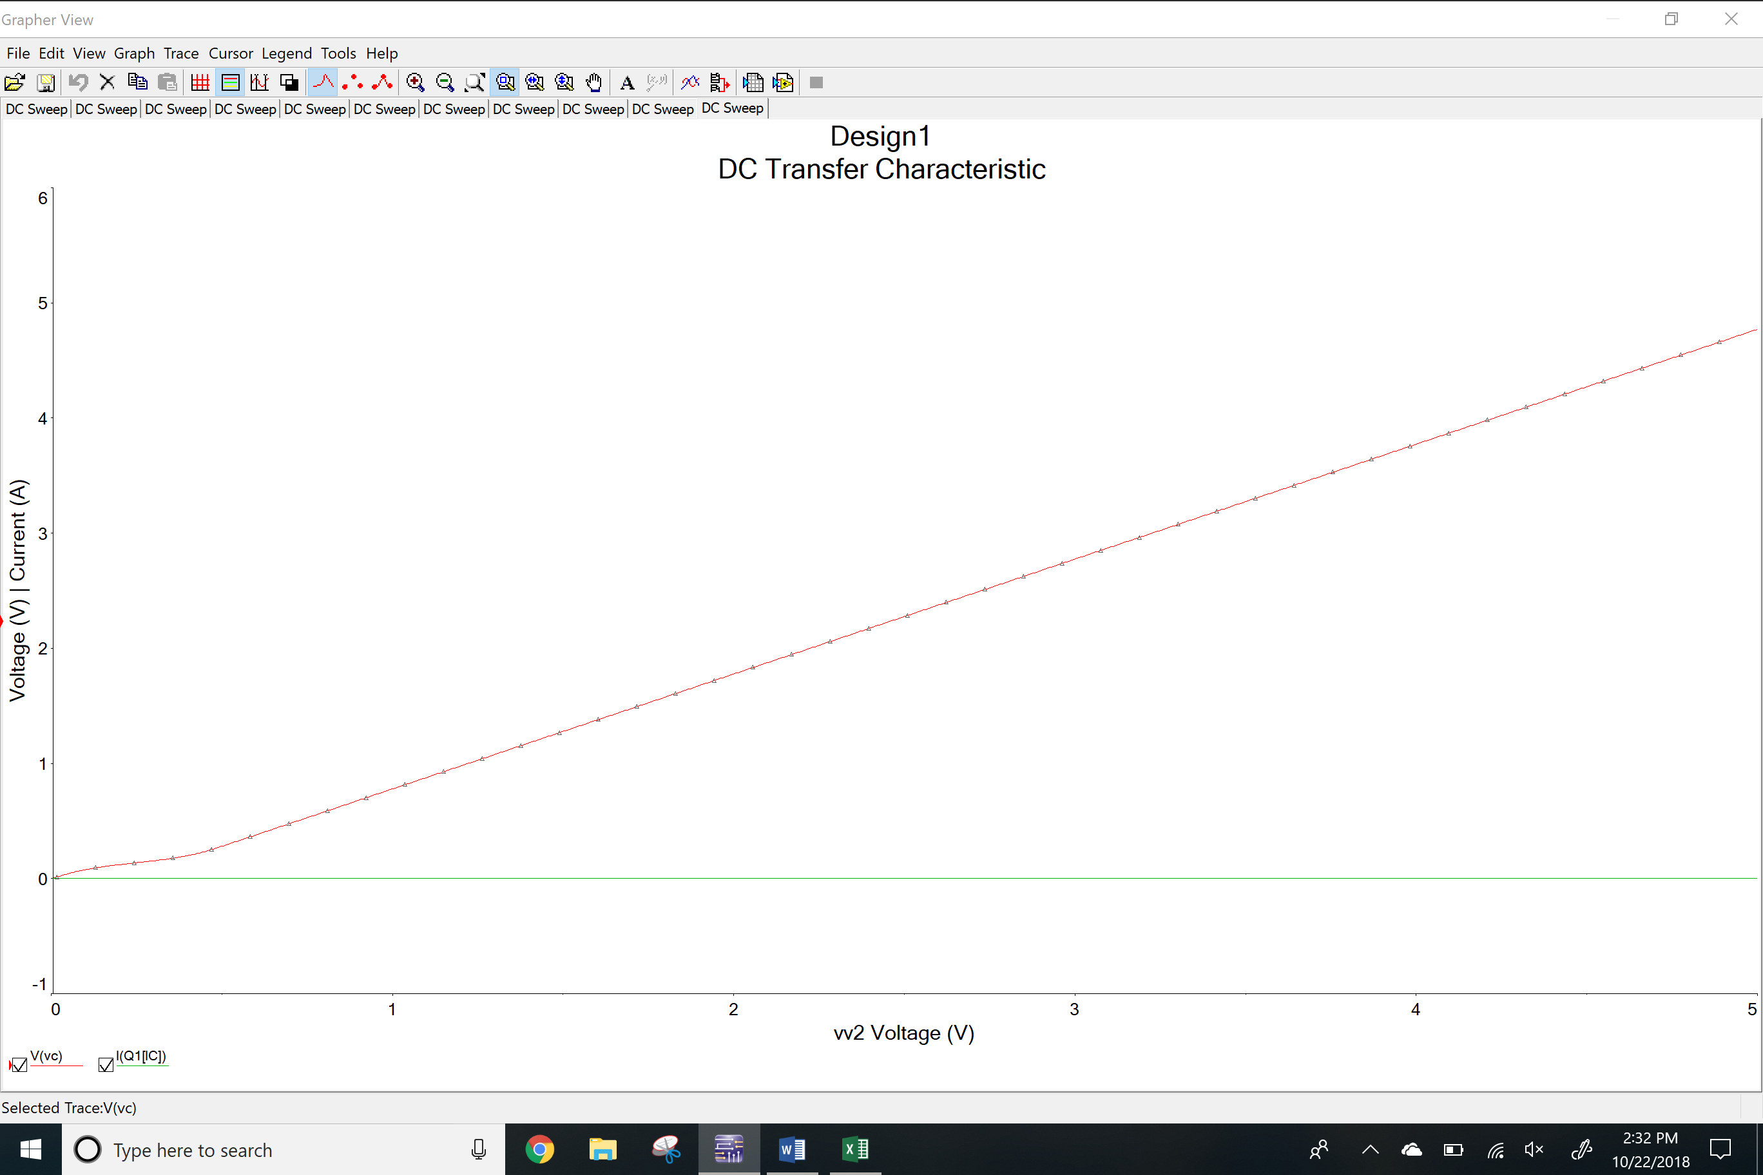

DC sweep of V2 Plot

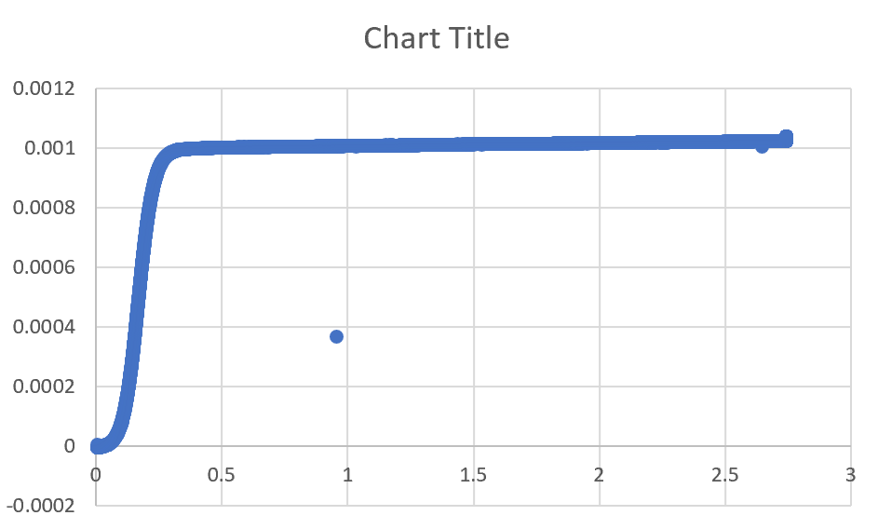

PNP BJT characteristic circuit

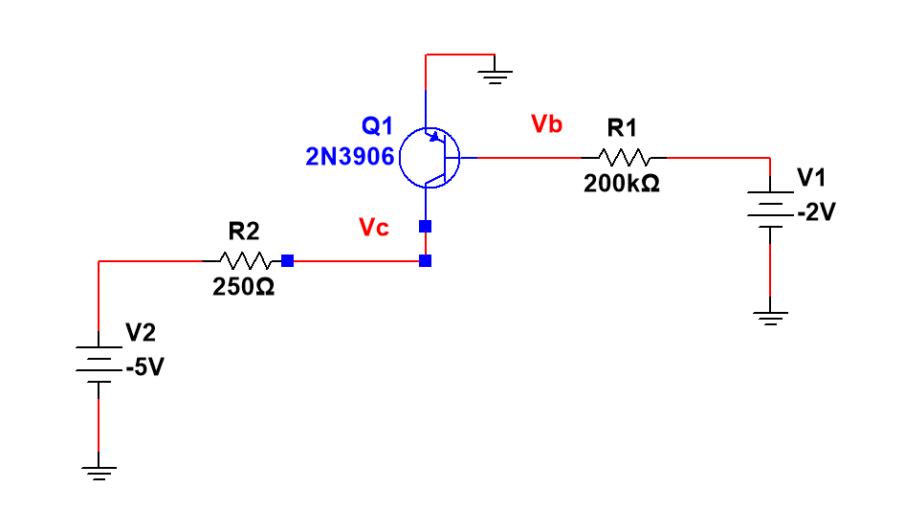

DC sweep of V1

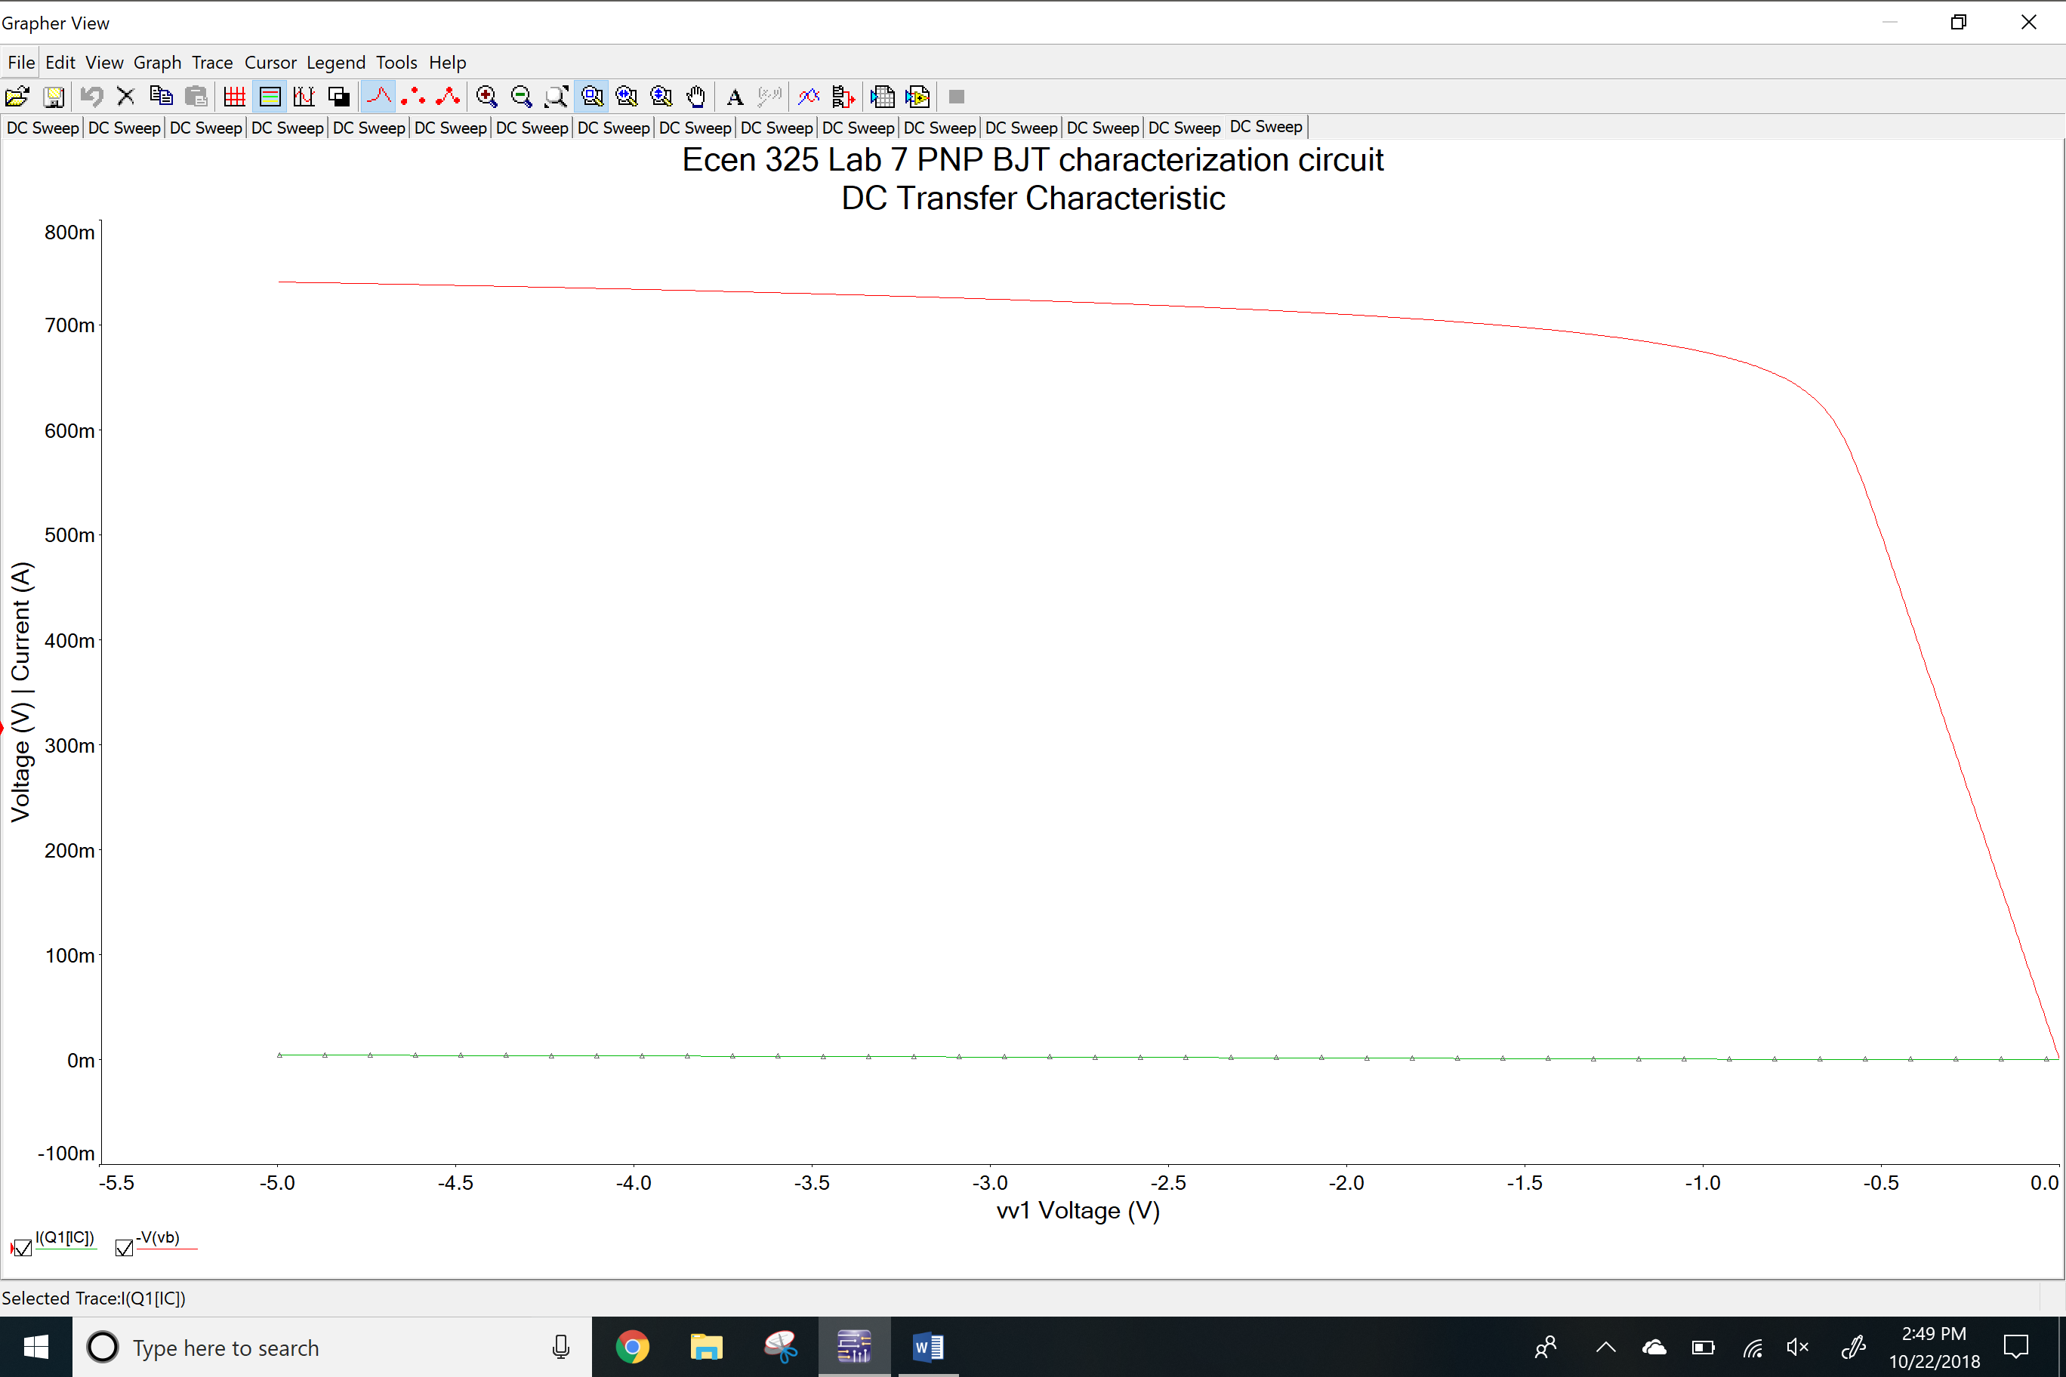

DC sweep of V1 Plot

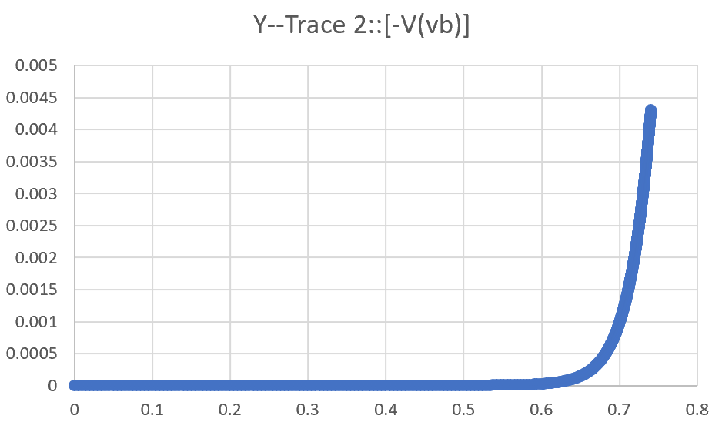DC sweep of V2

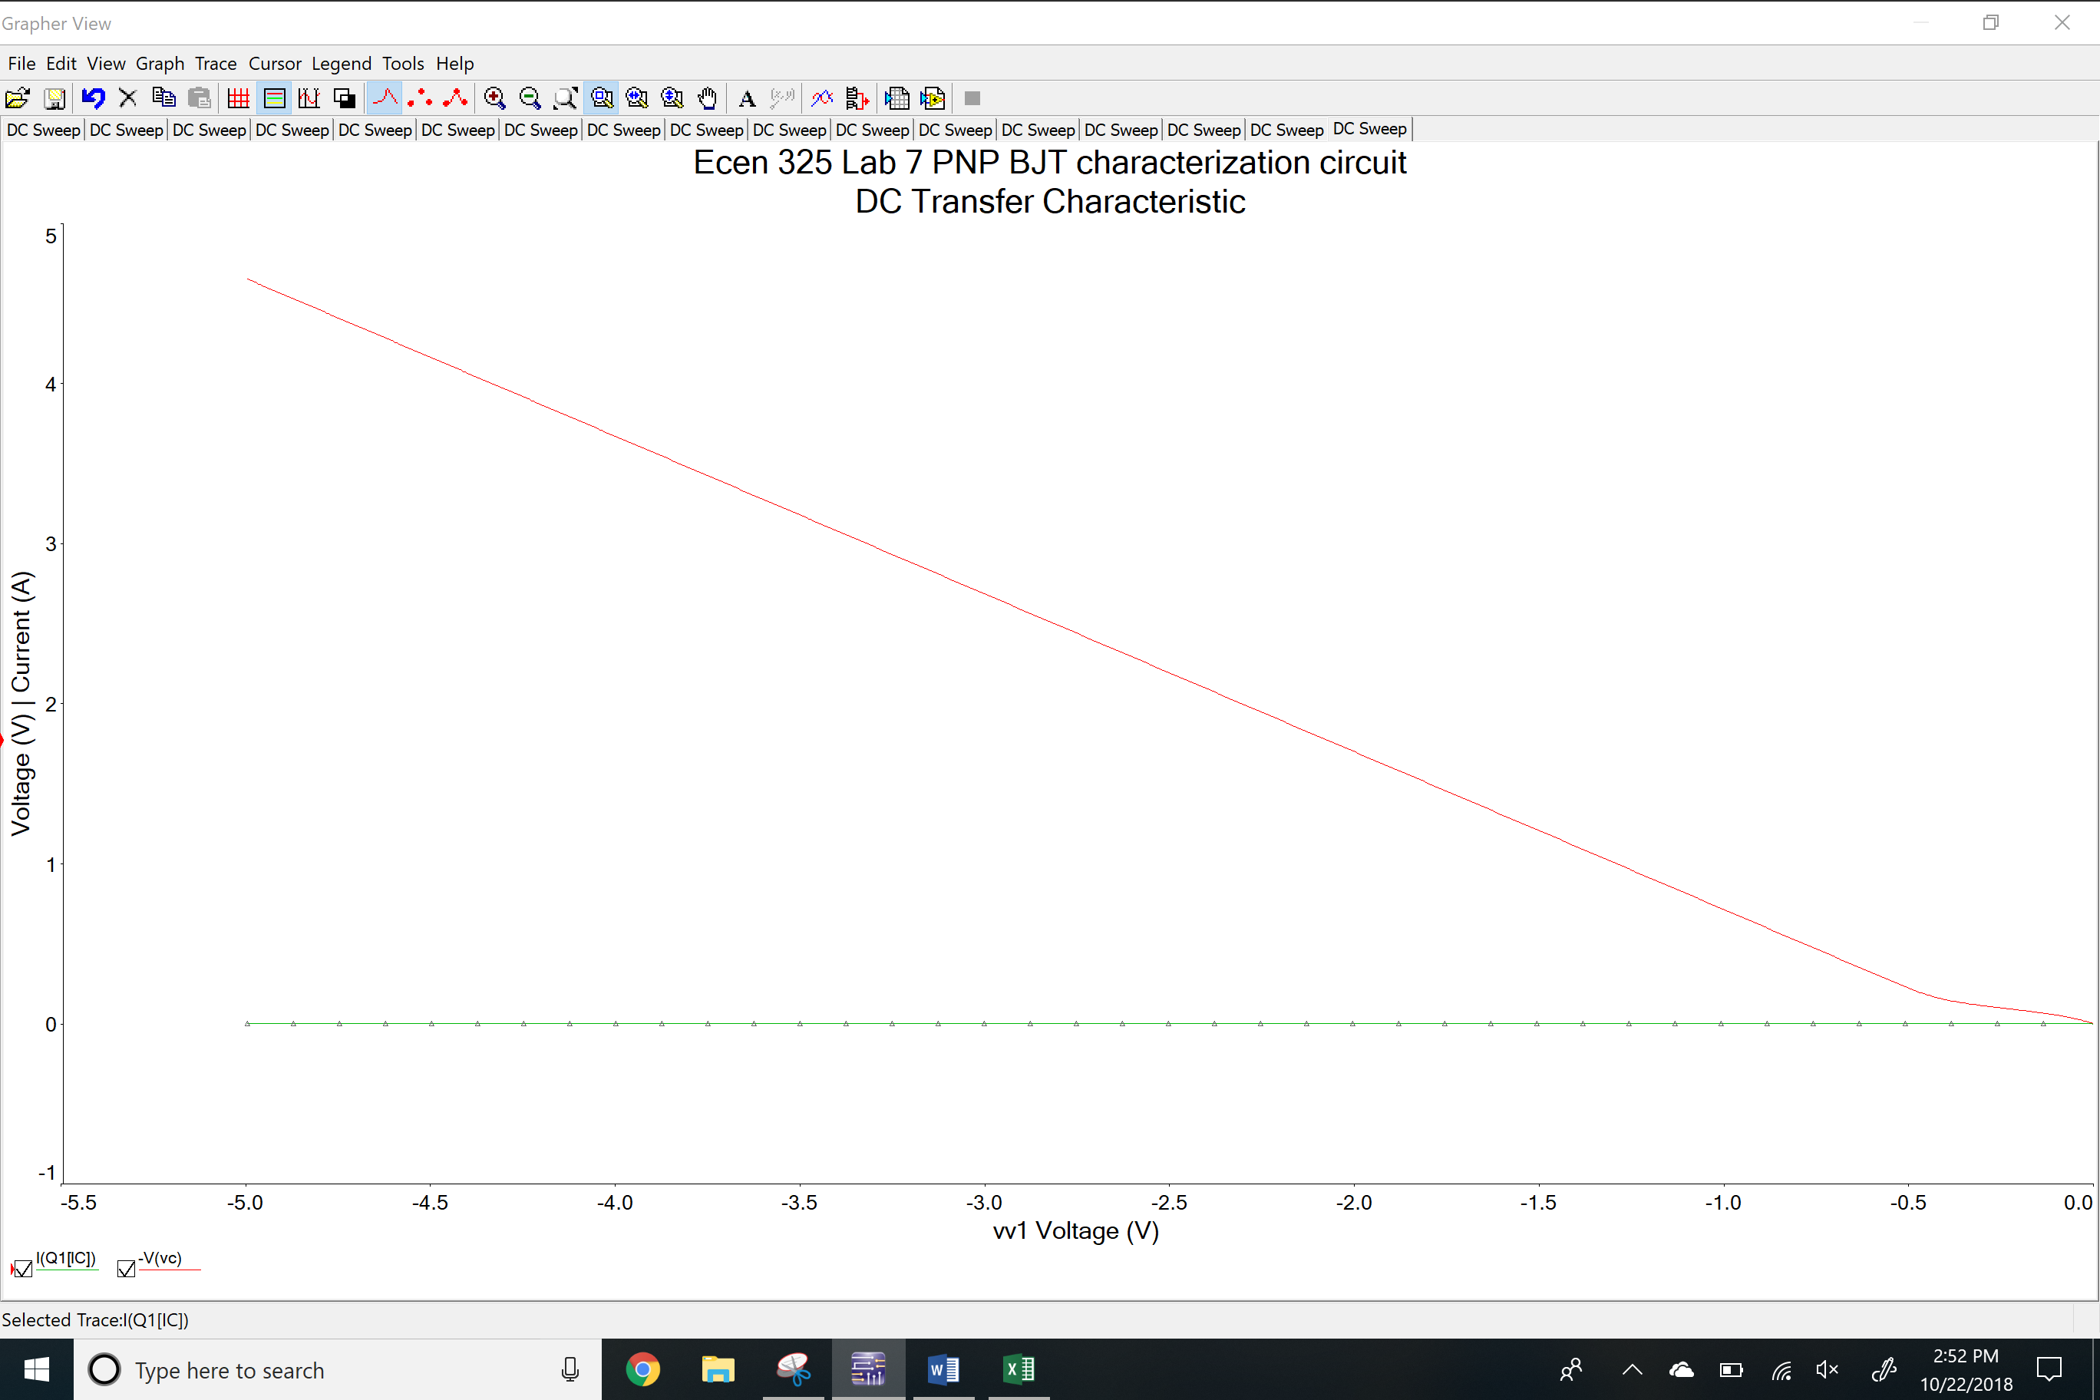

DC sweep of V2 Plot

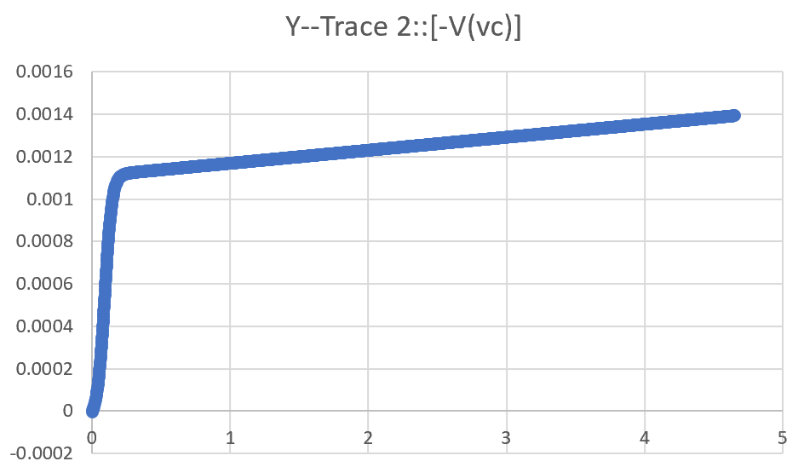NPN DC biasing circuit

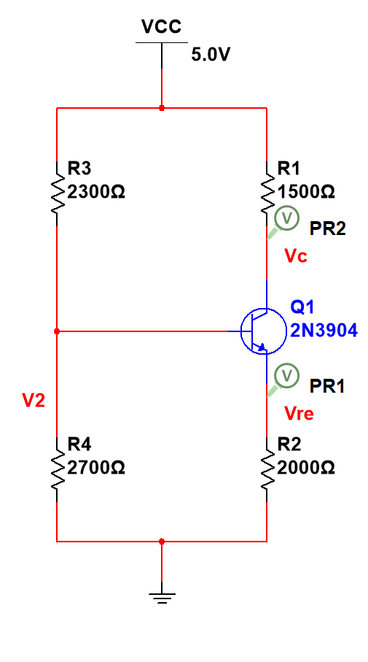

DC operating point

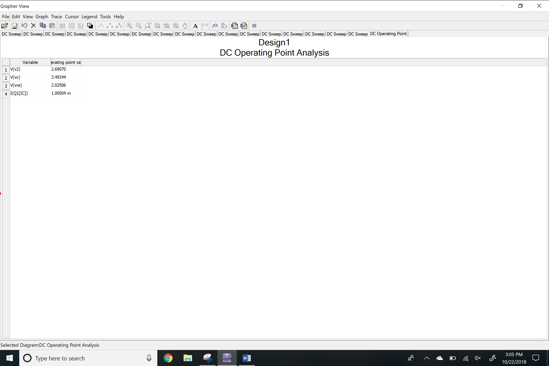PNP DC biasing circuit

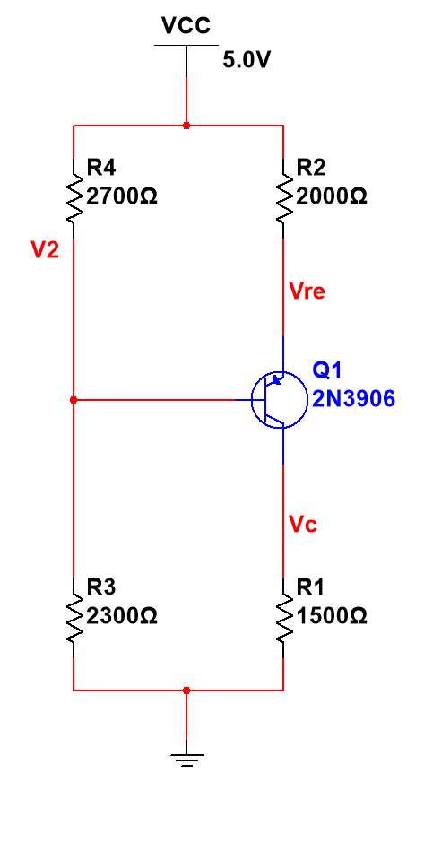

DC operating point

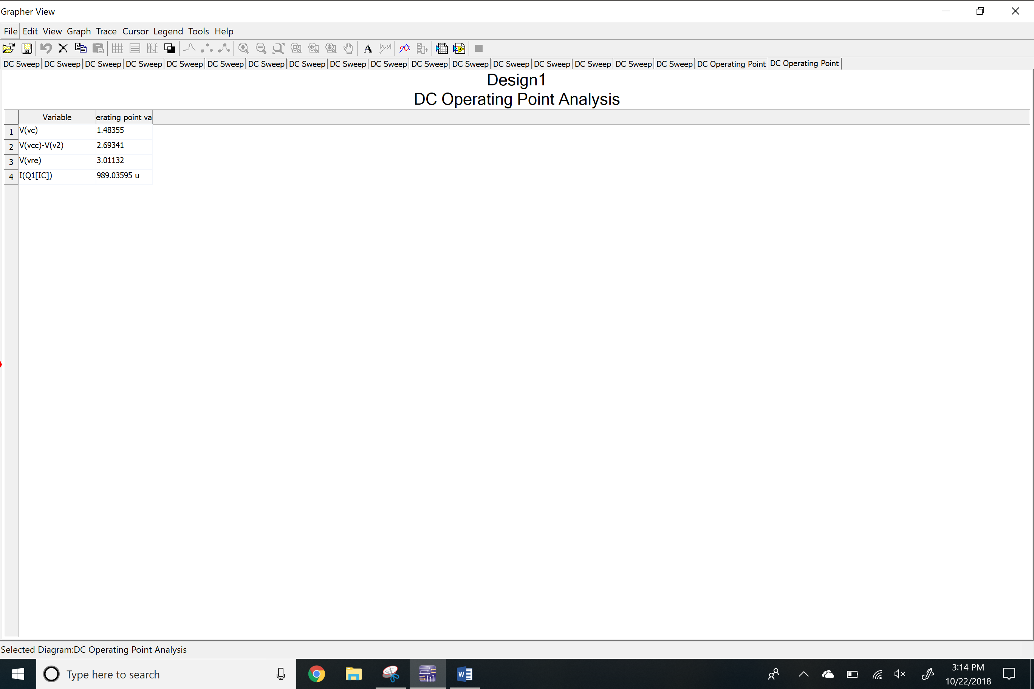

NPN BJT using current source

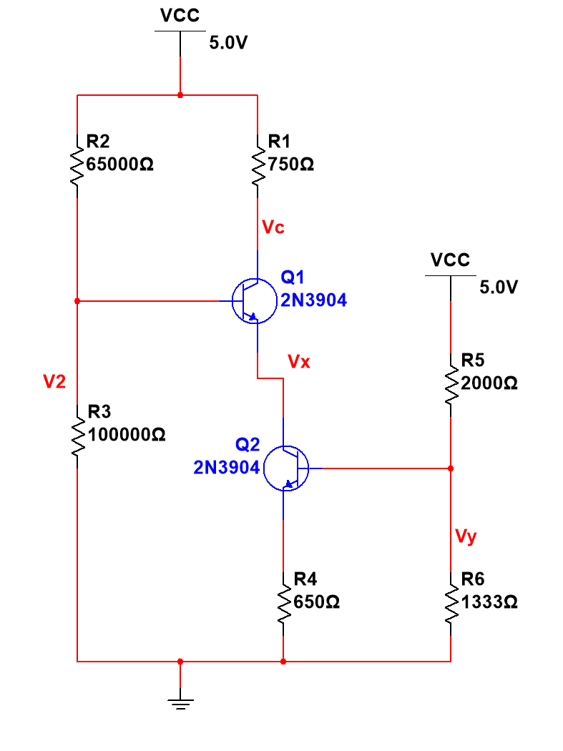

DC operating point

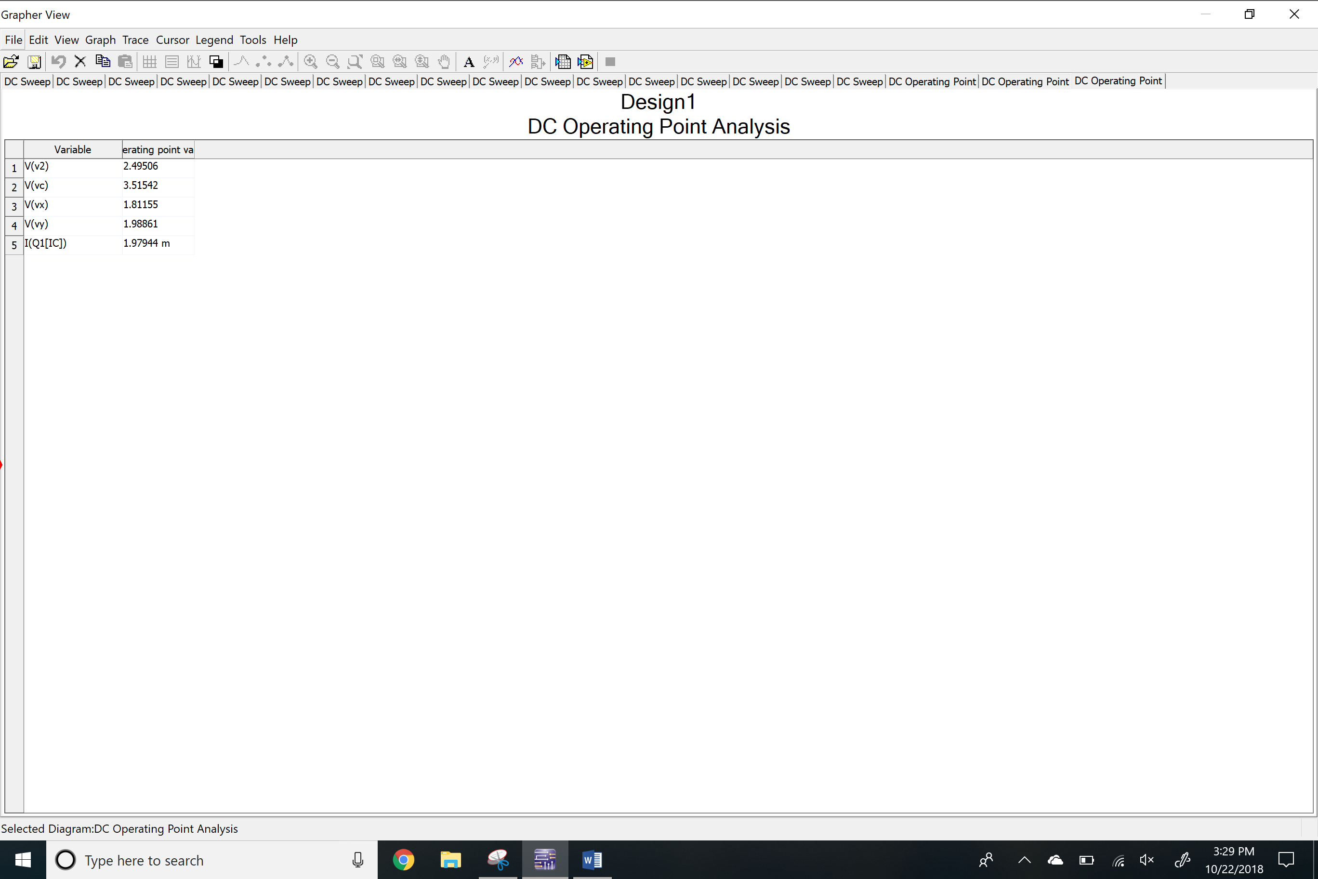

PNP BJT using current source

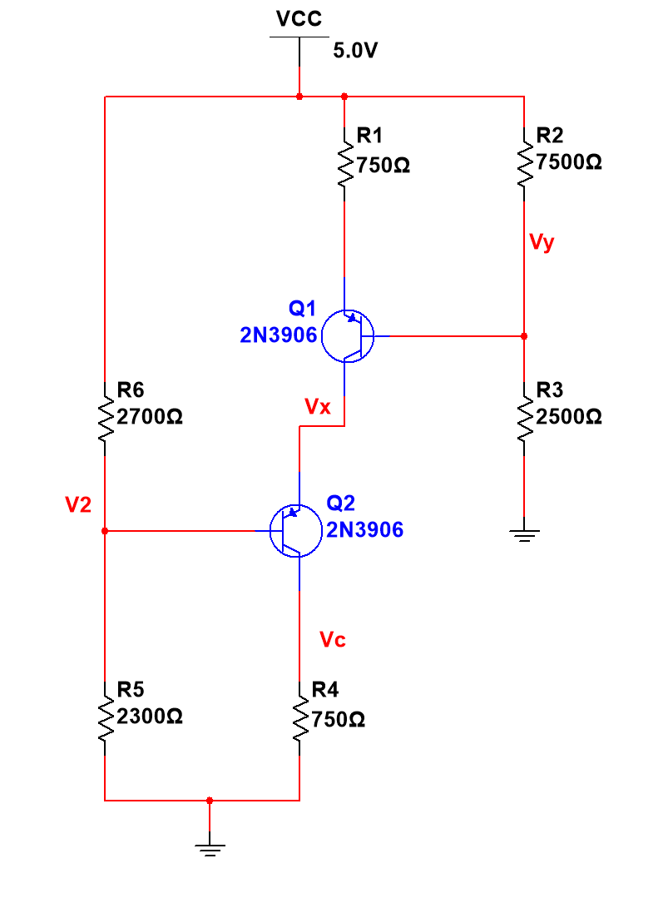

DC operating point

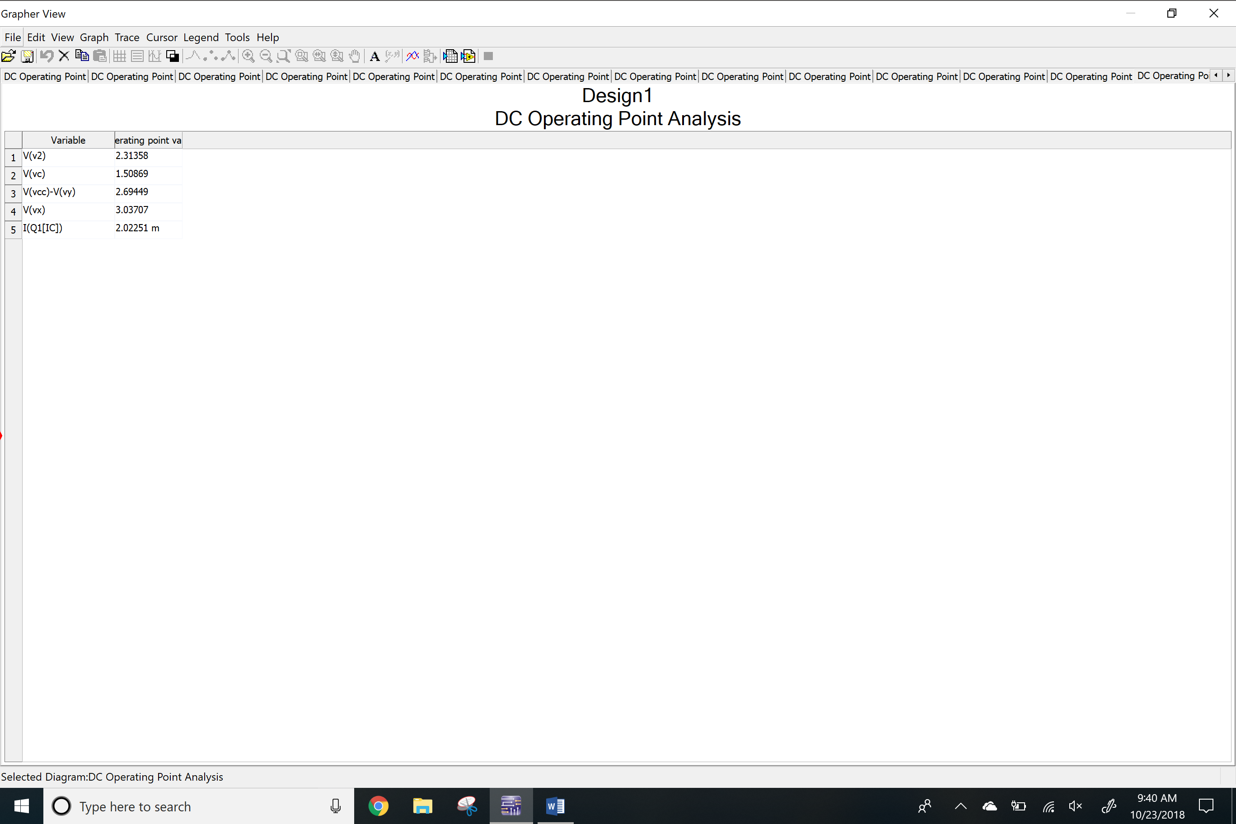

**Measurements**

NPN characterization circuit

Scope with ramp up V1 signal

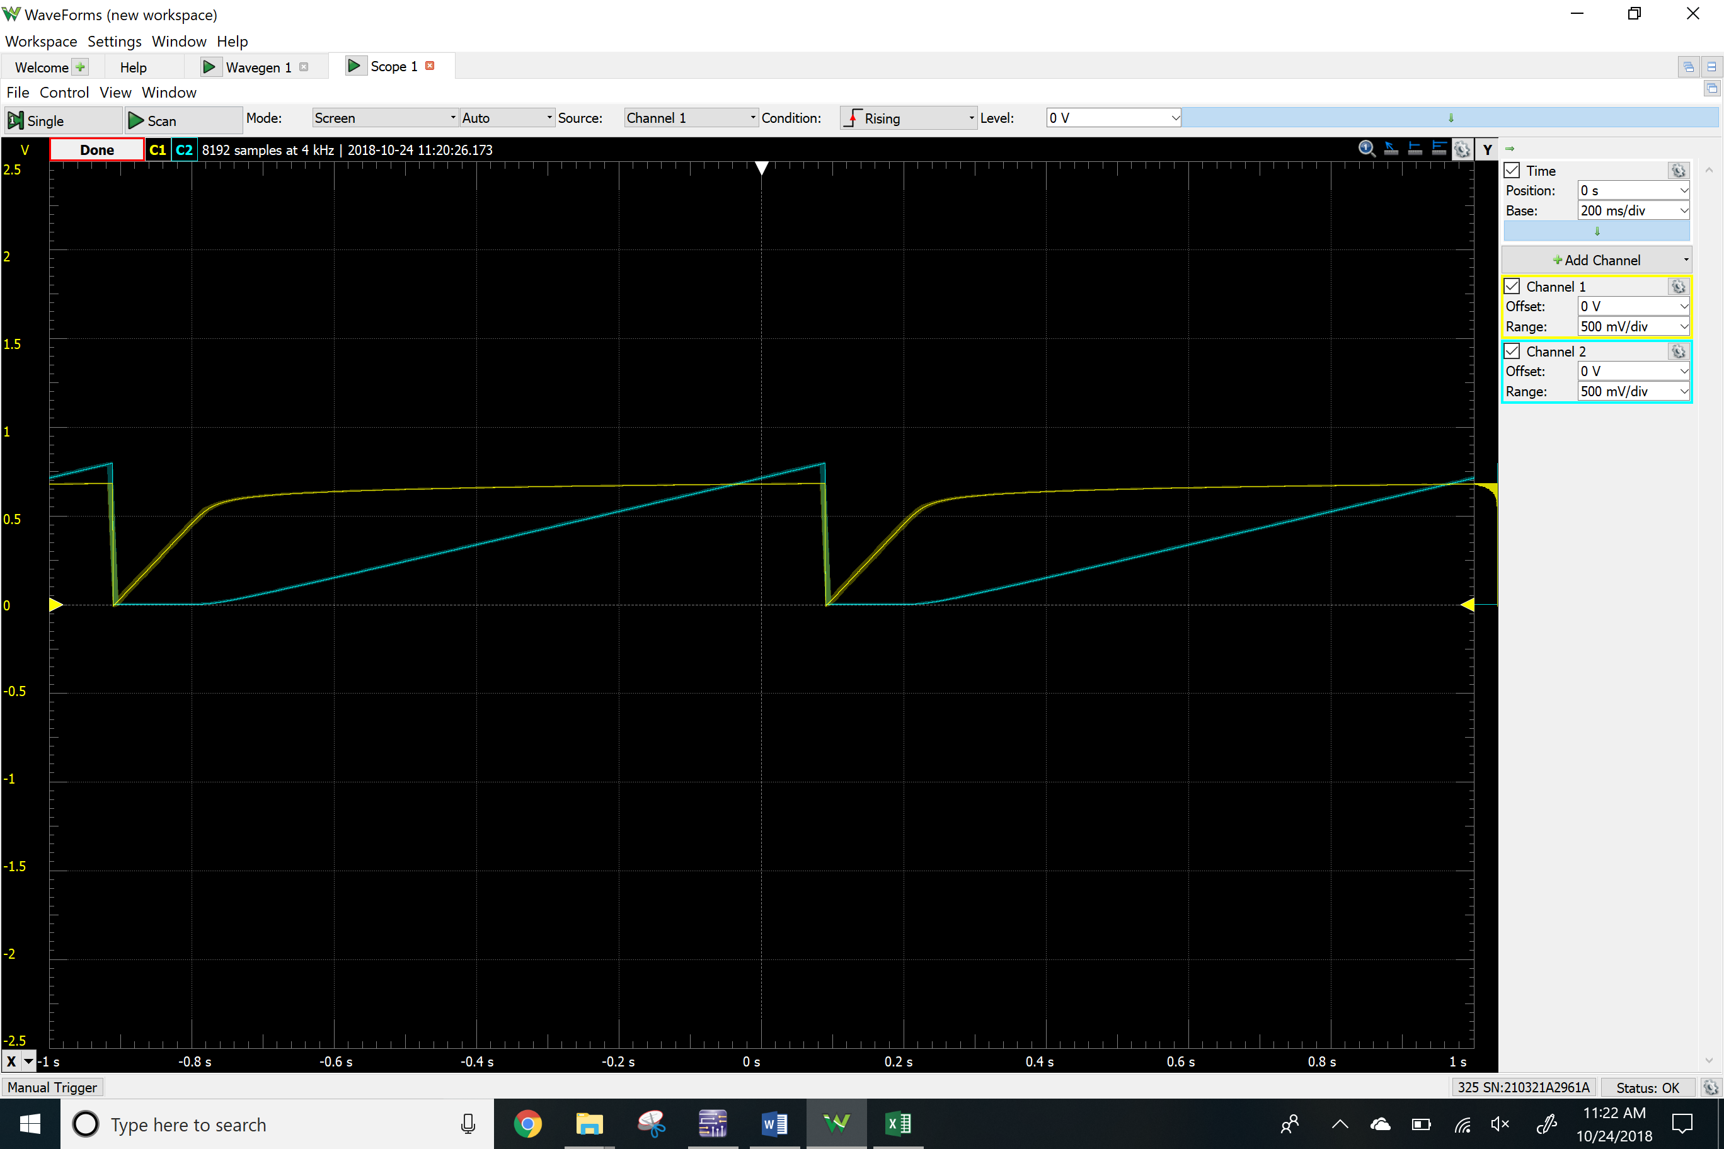

Plot



Scope with ramp up V2 signal

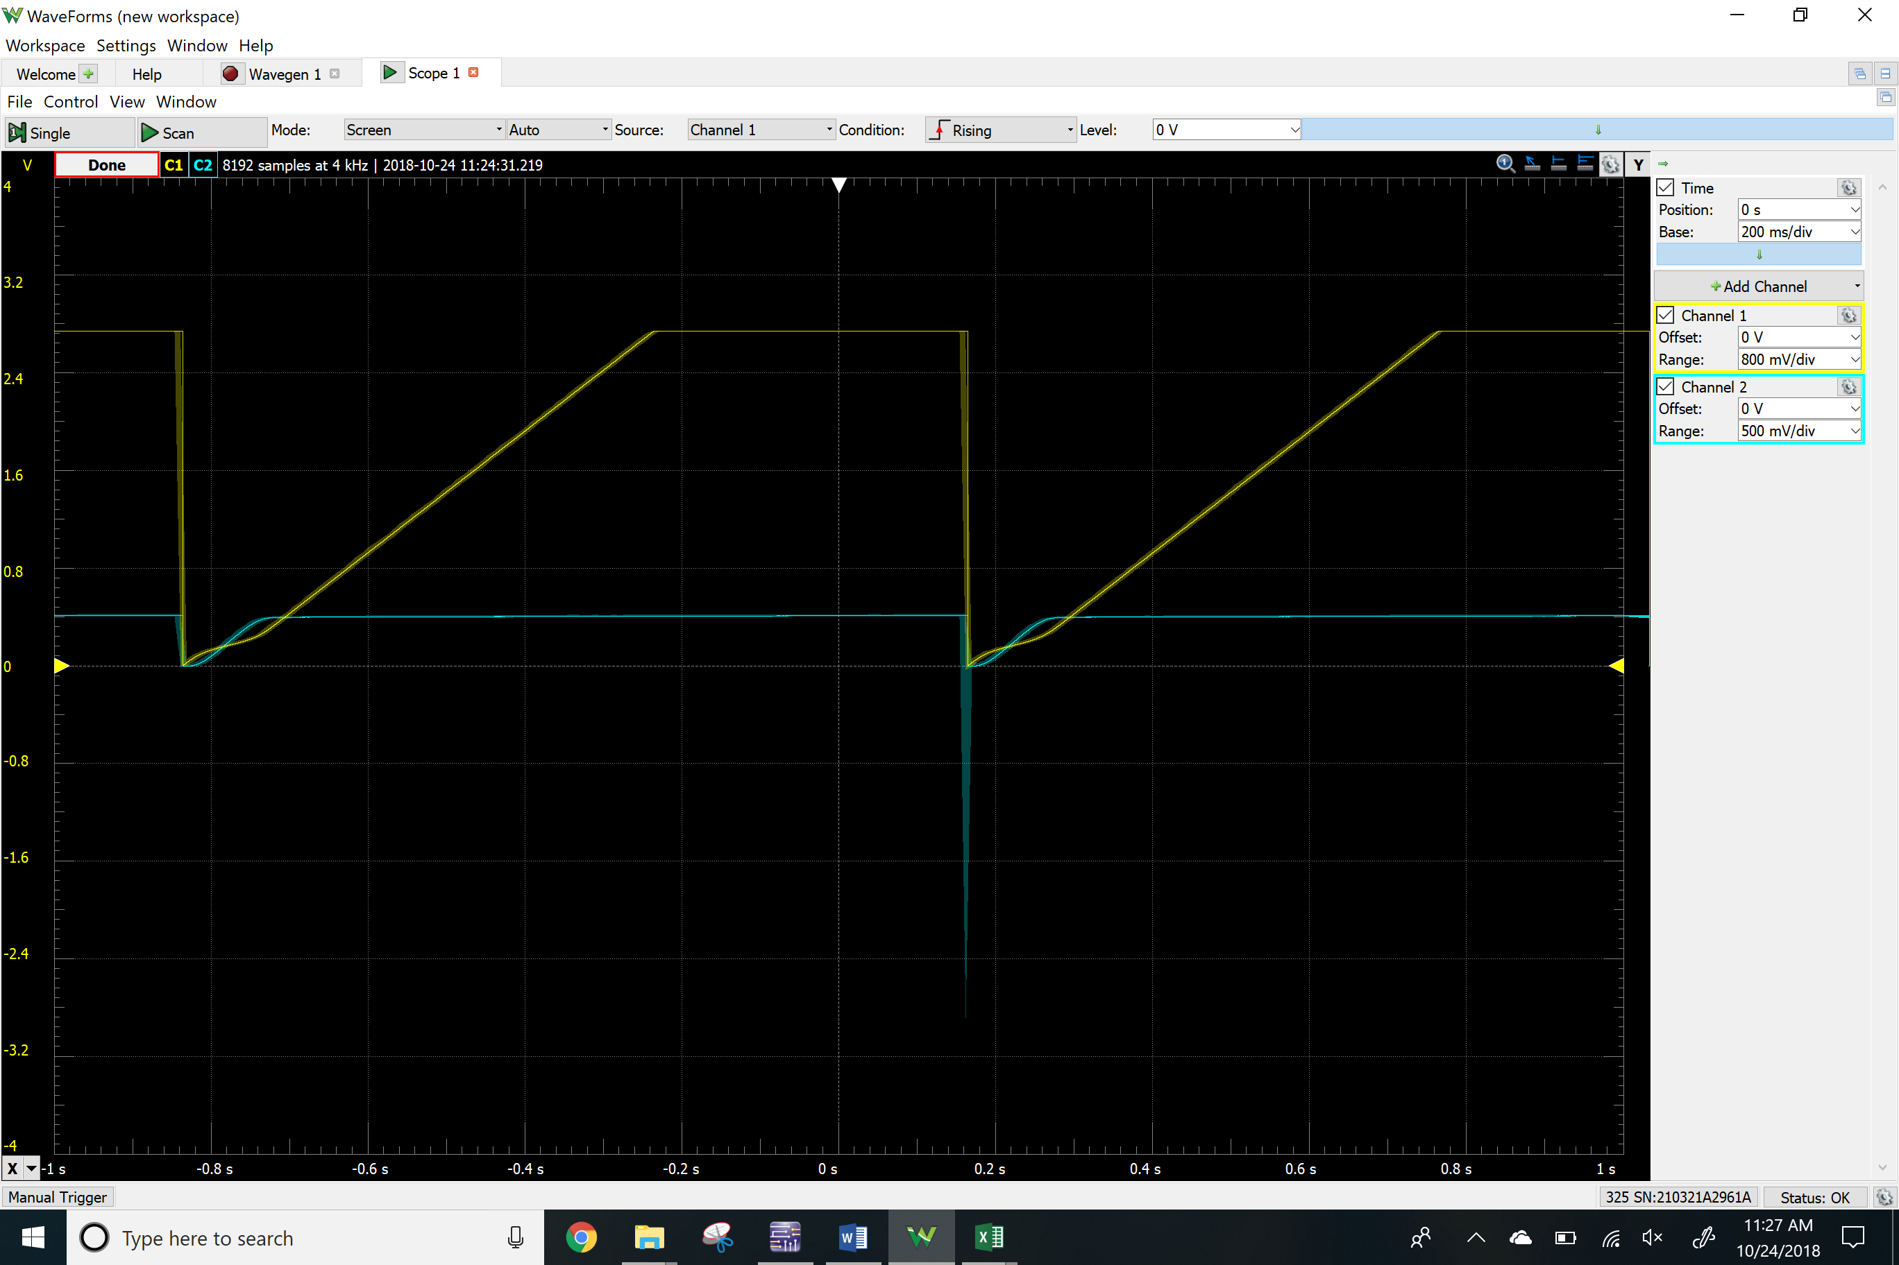

Plot



PNP characterization circuit

Scope with ramp up V1 signal

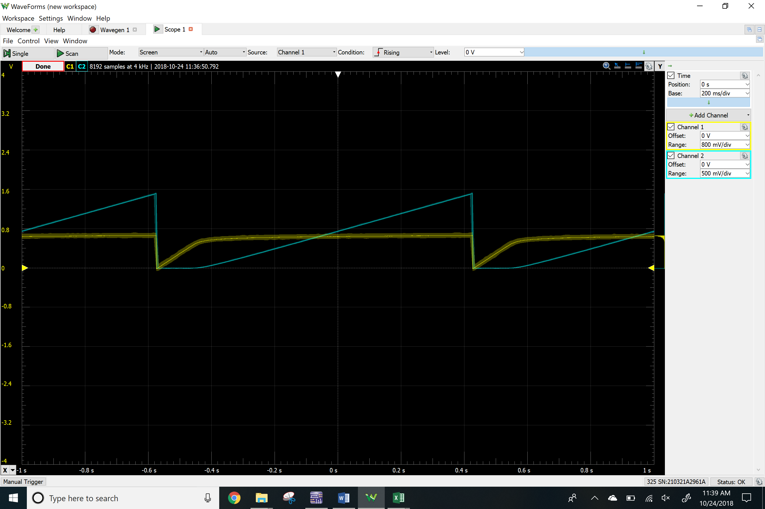Plot



Scope with ramp up V2 signal

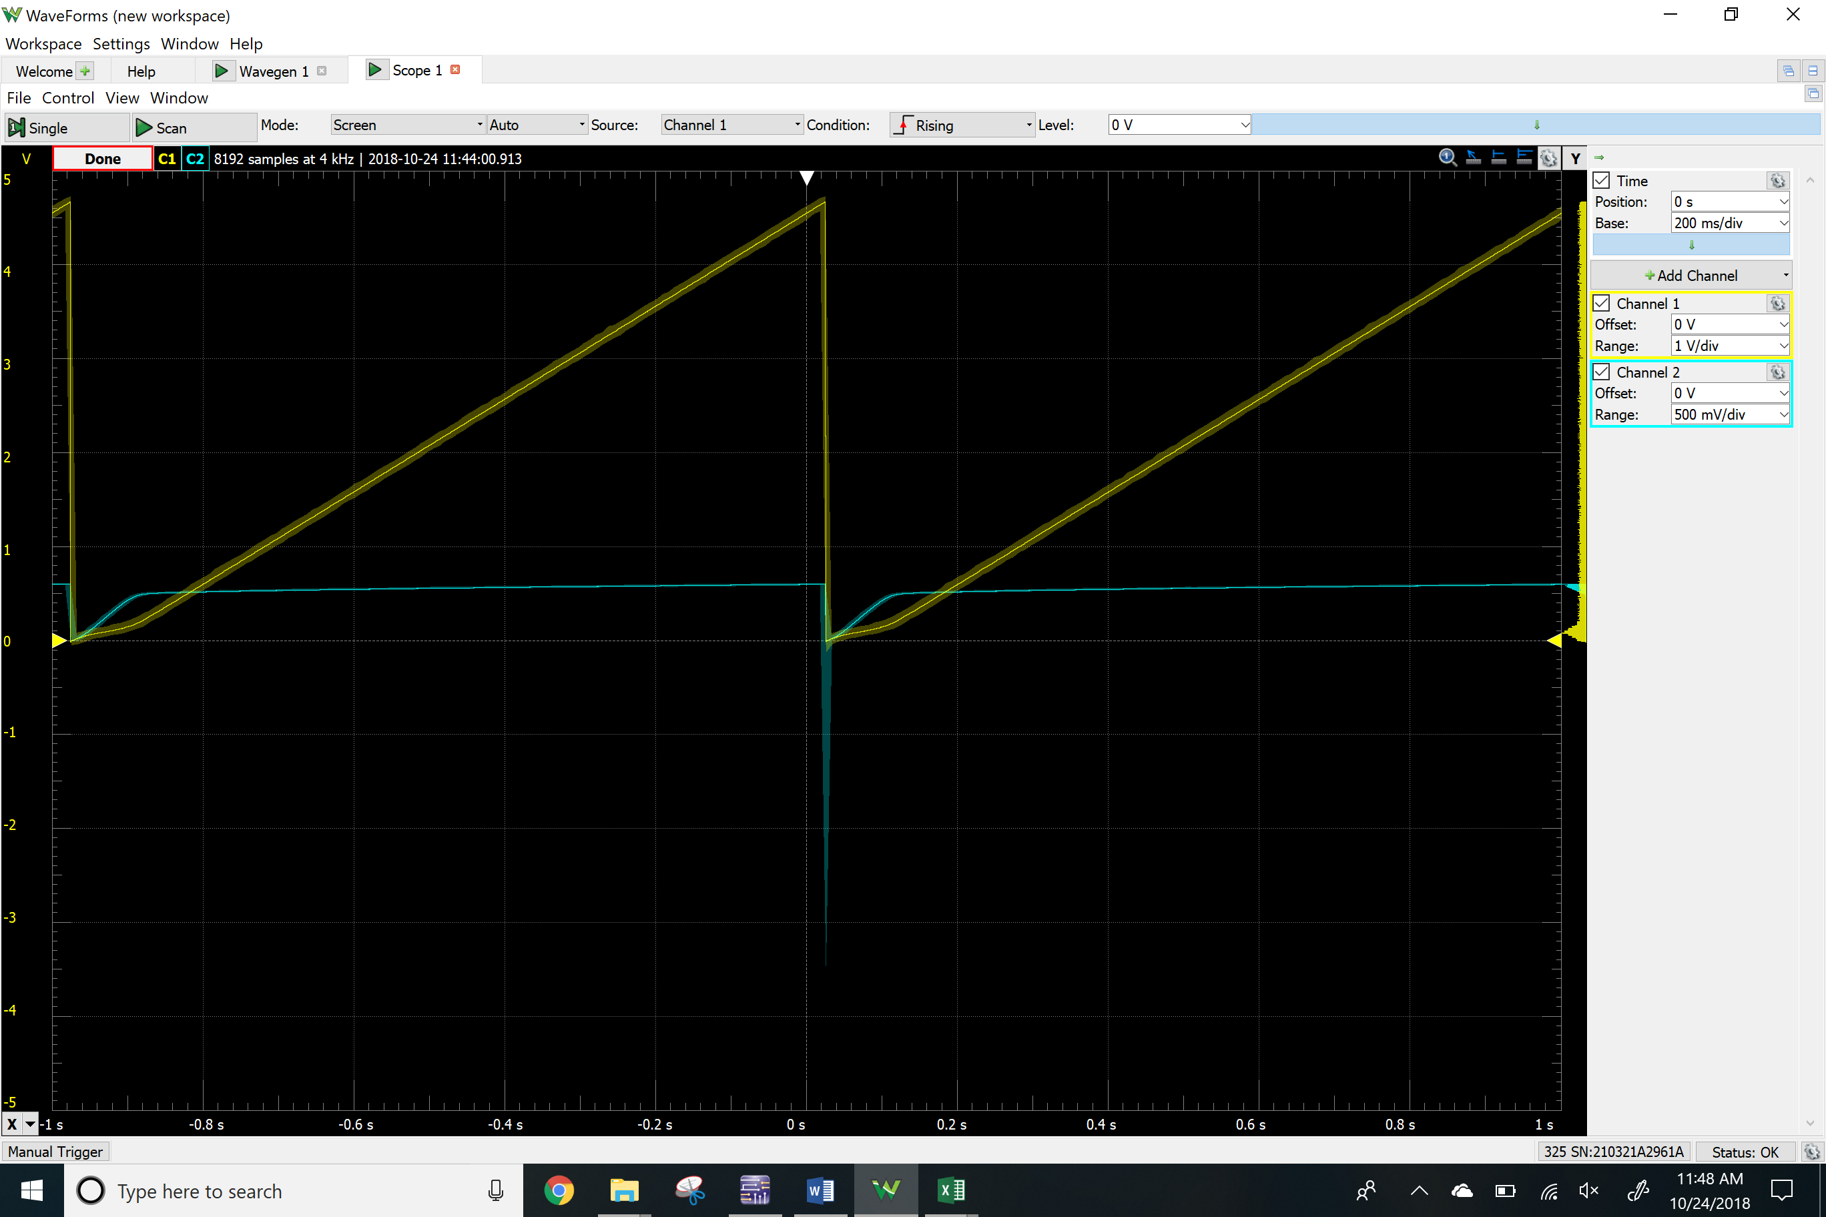Plot



NPN DC biasing circuit

V2

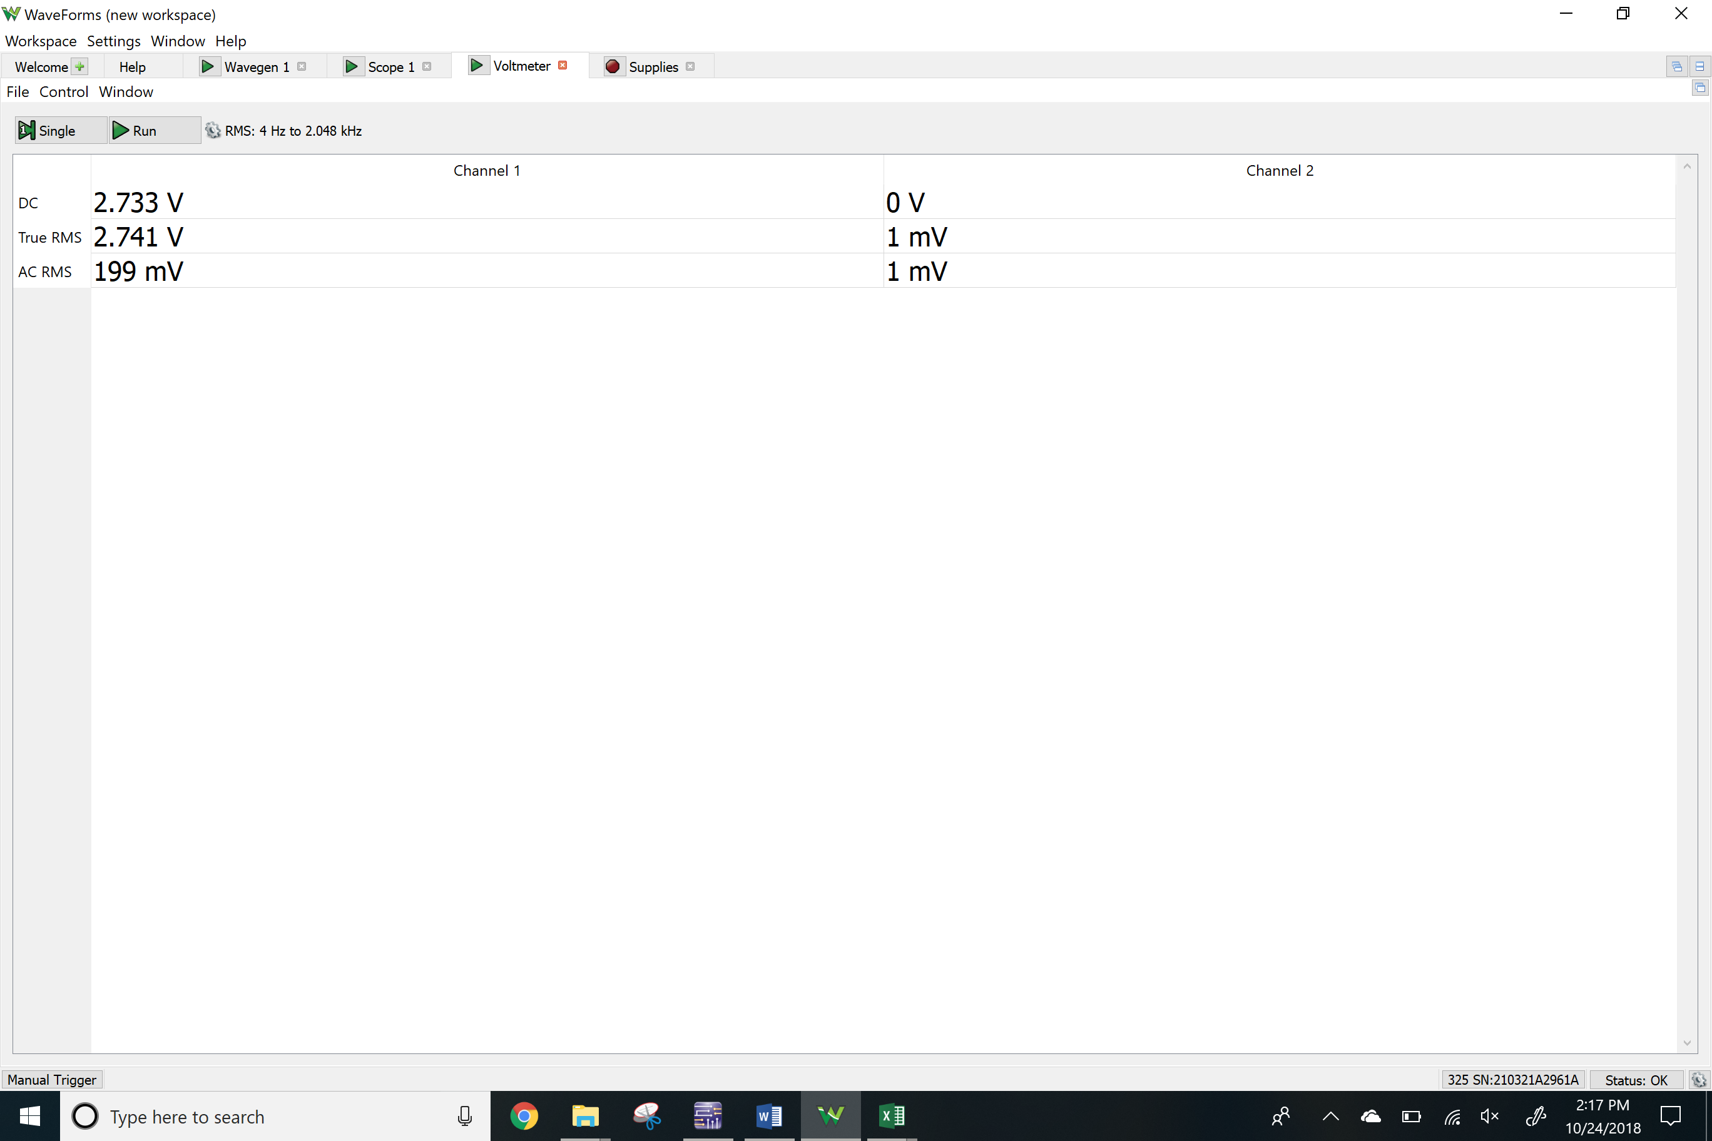

Vre

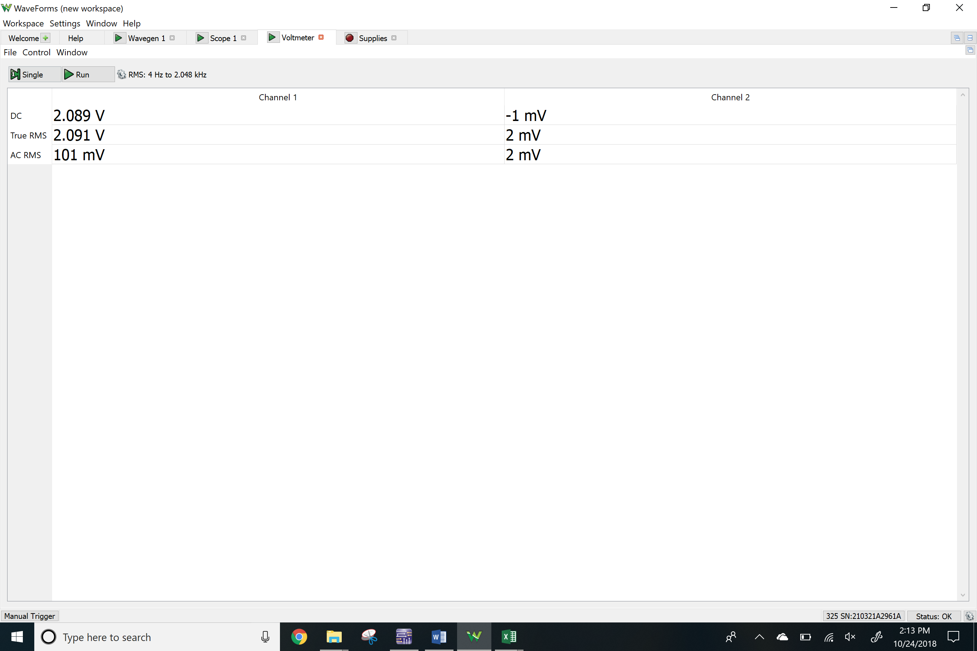

Vc

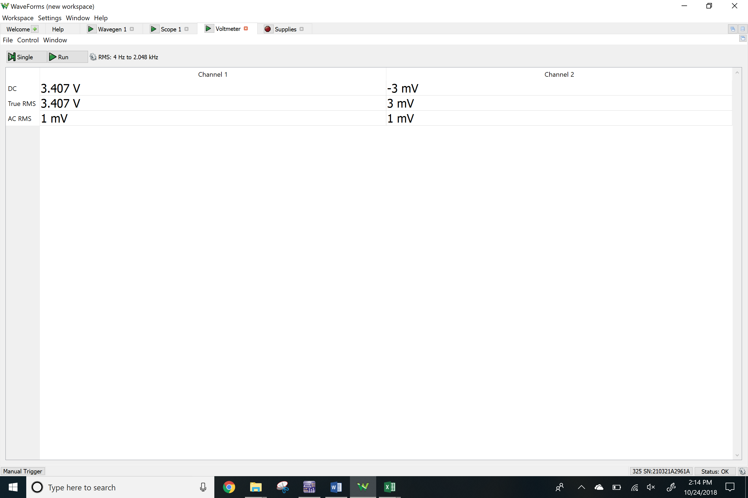

PNP DC biasing circuit

V2

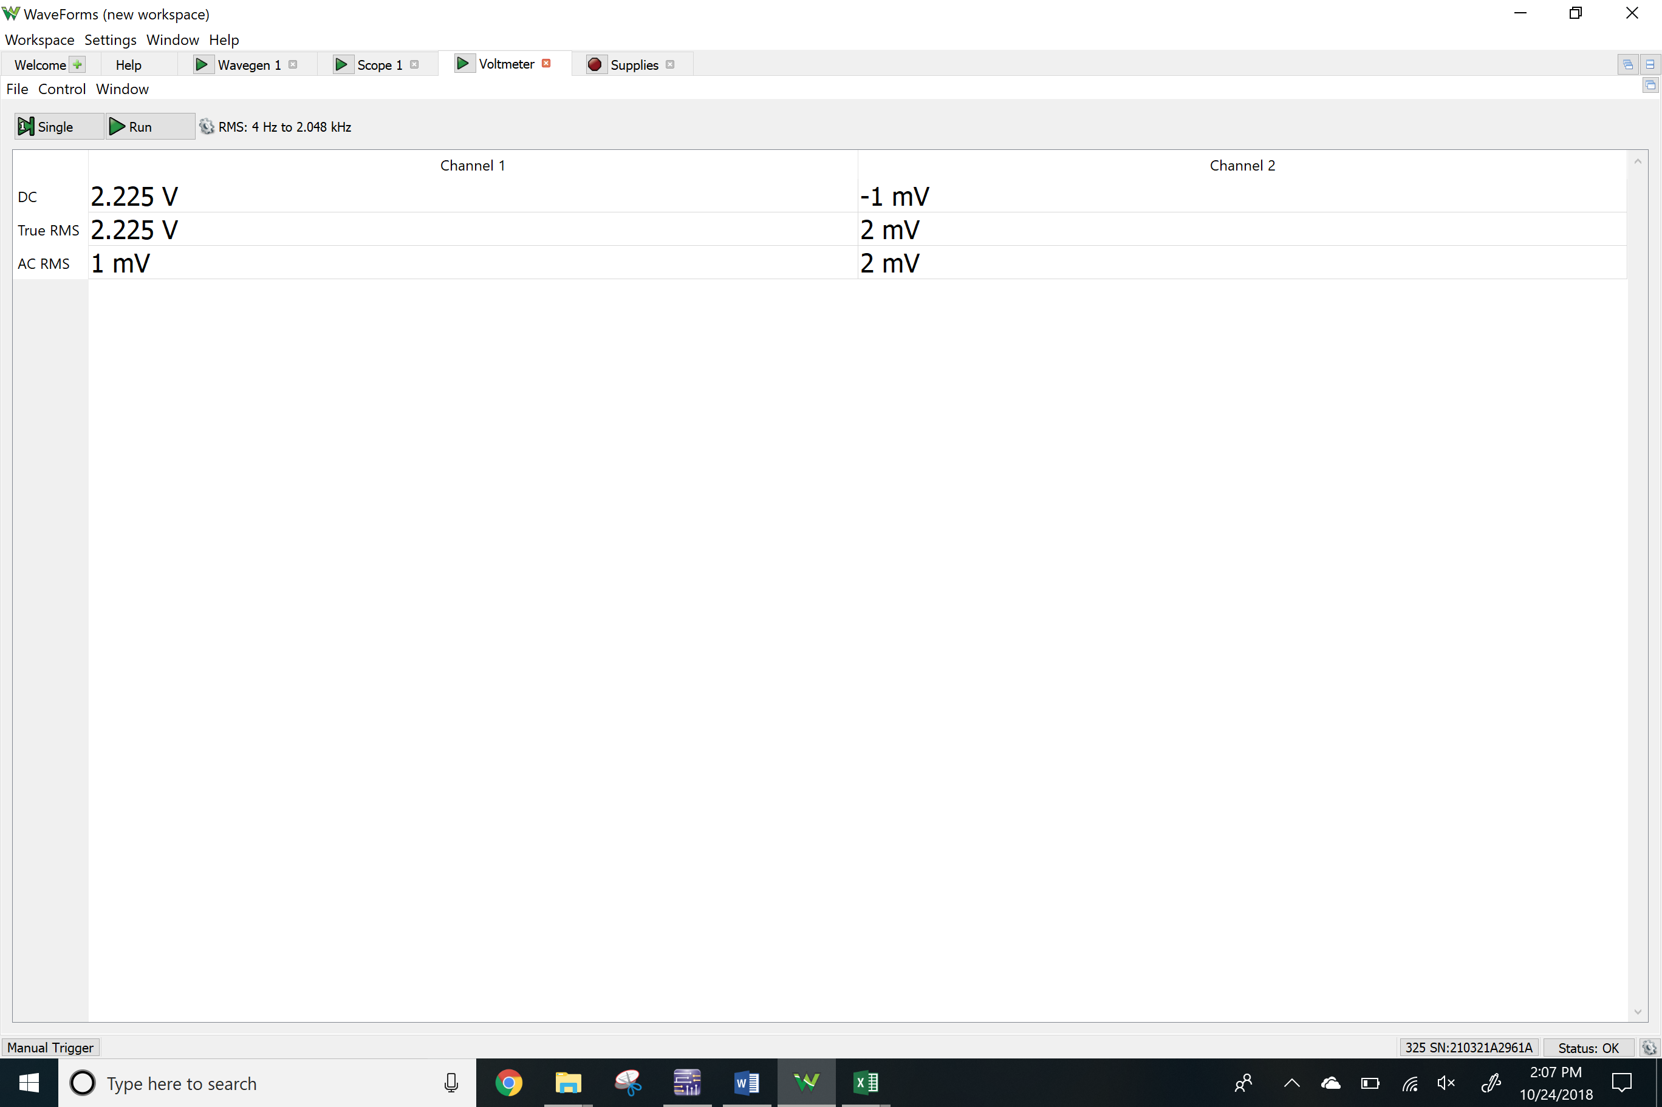Vre

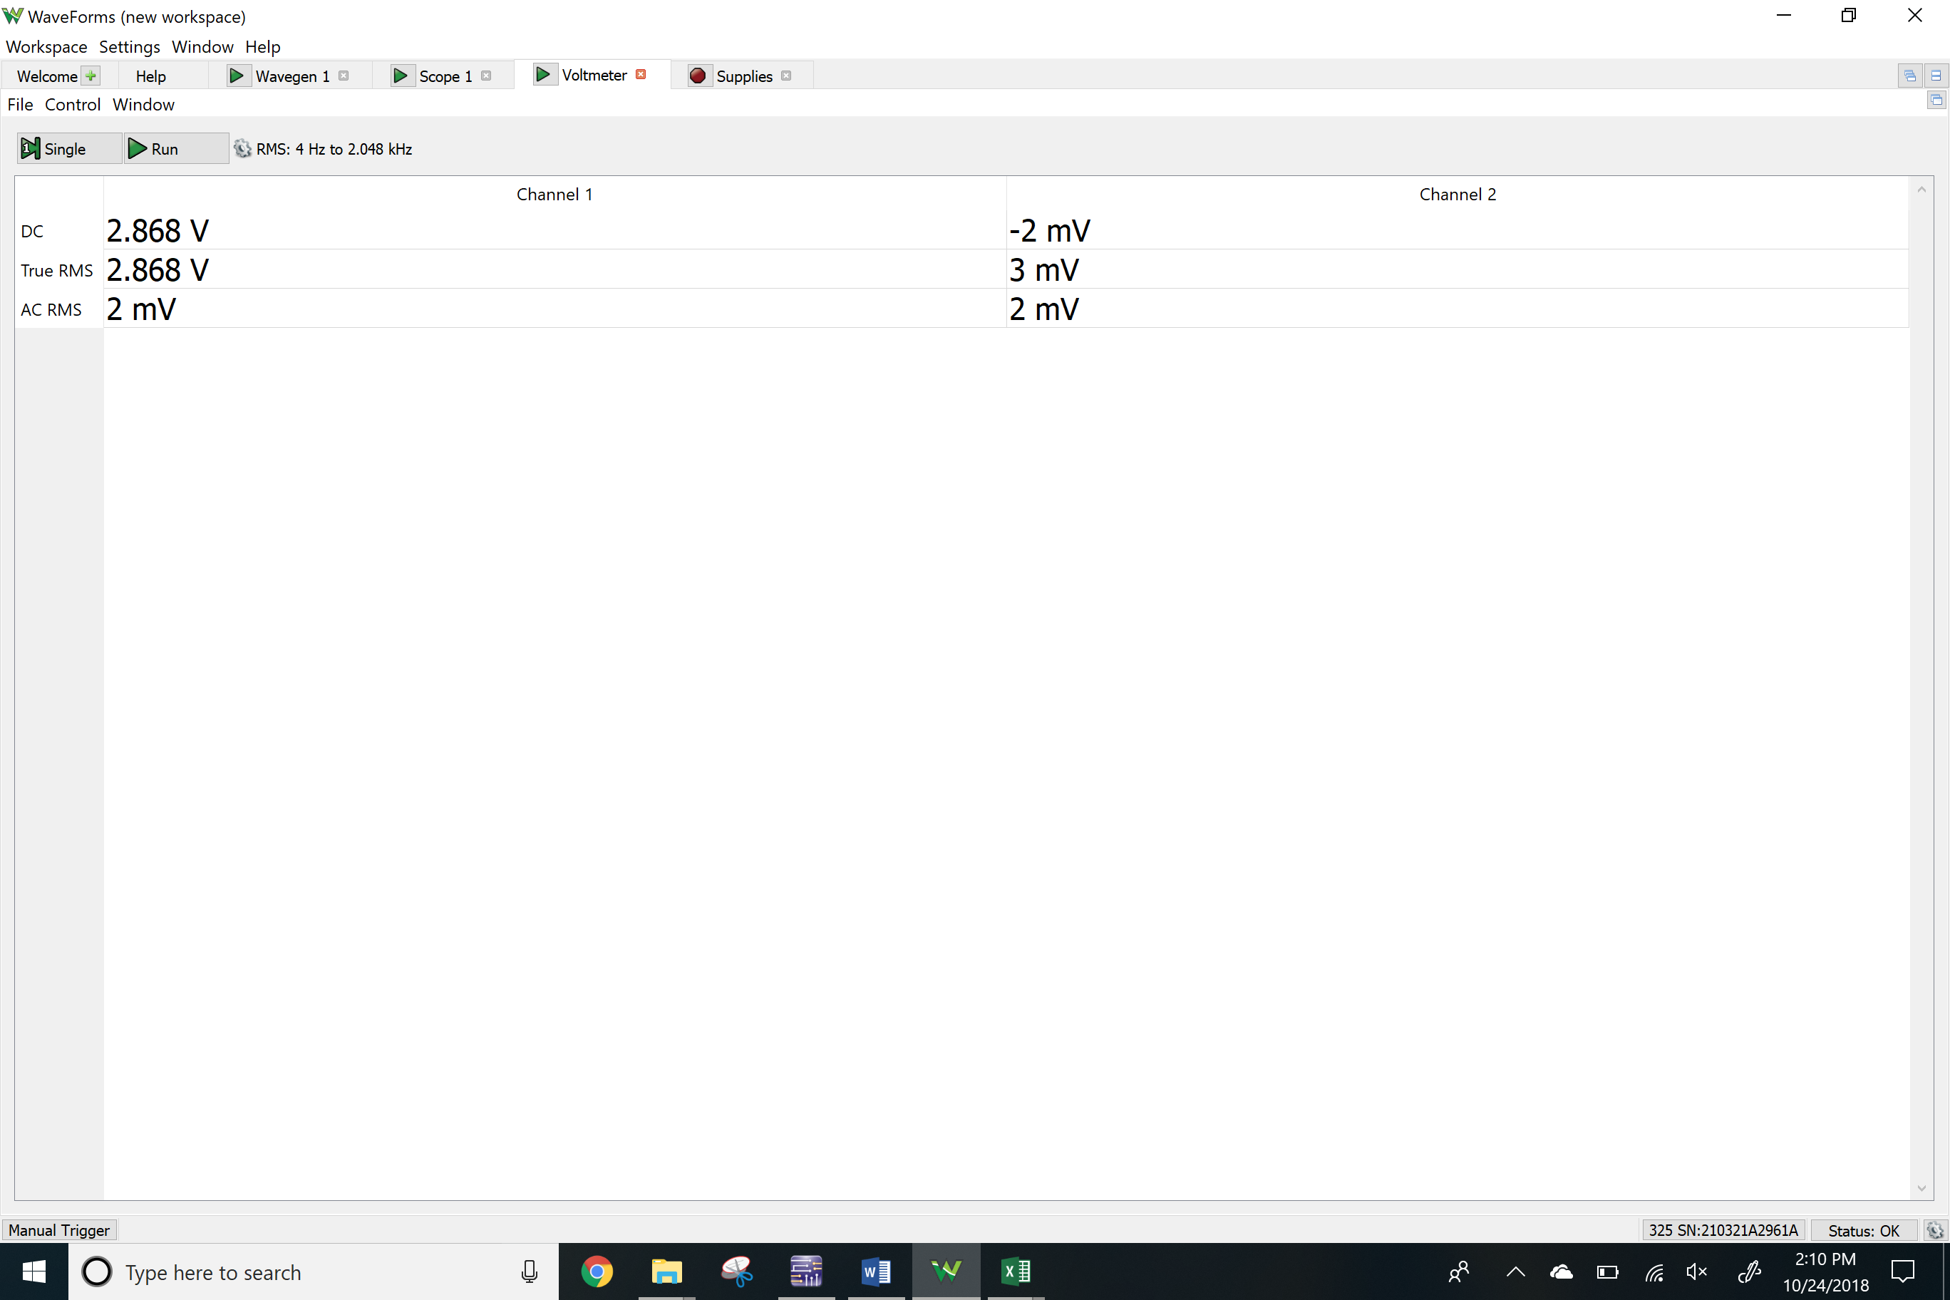

Vc

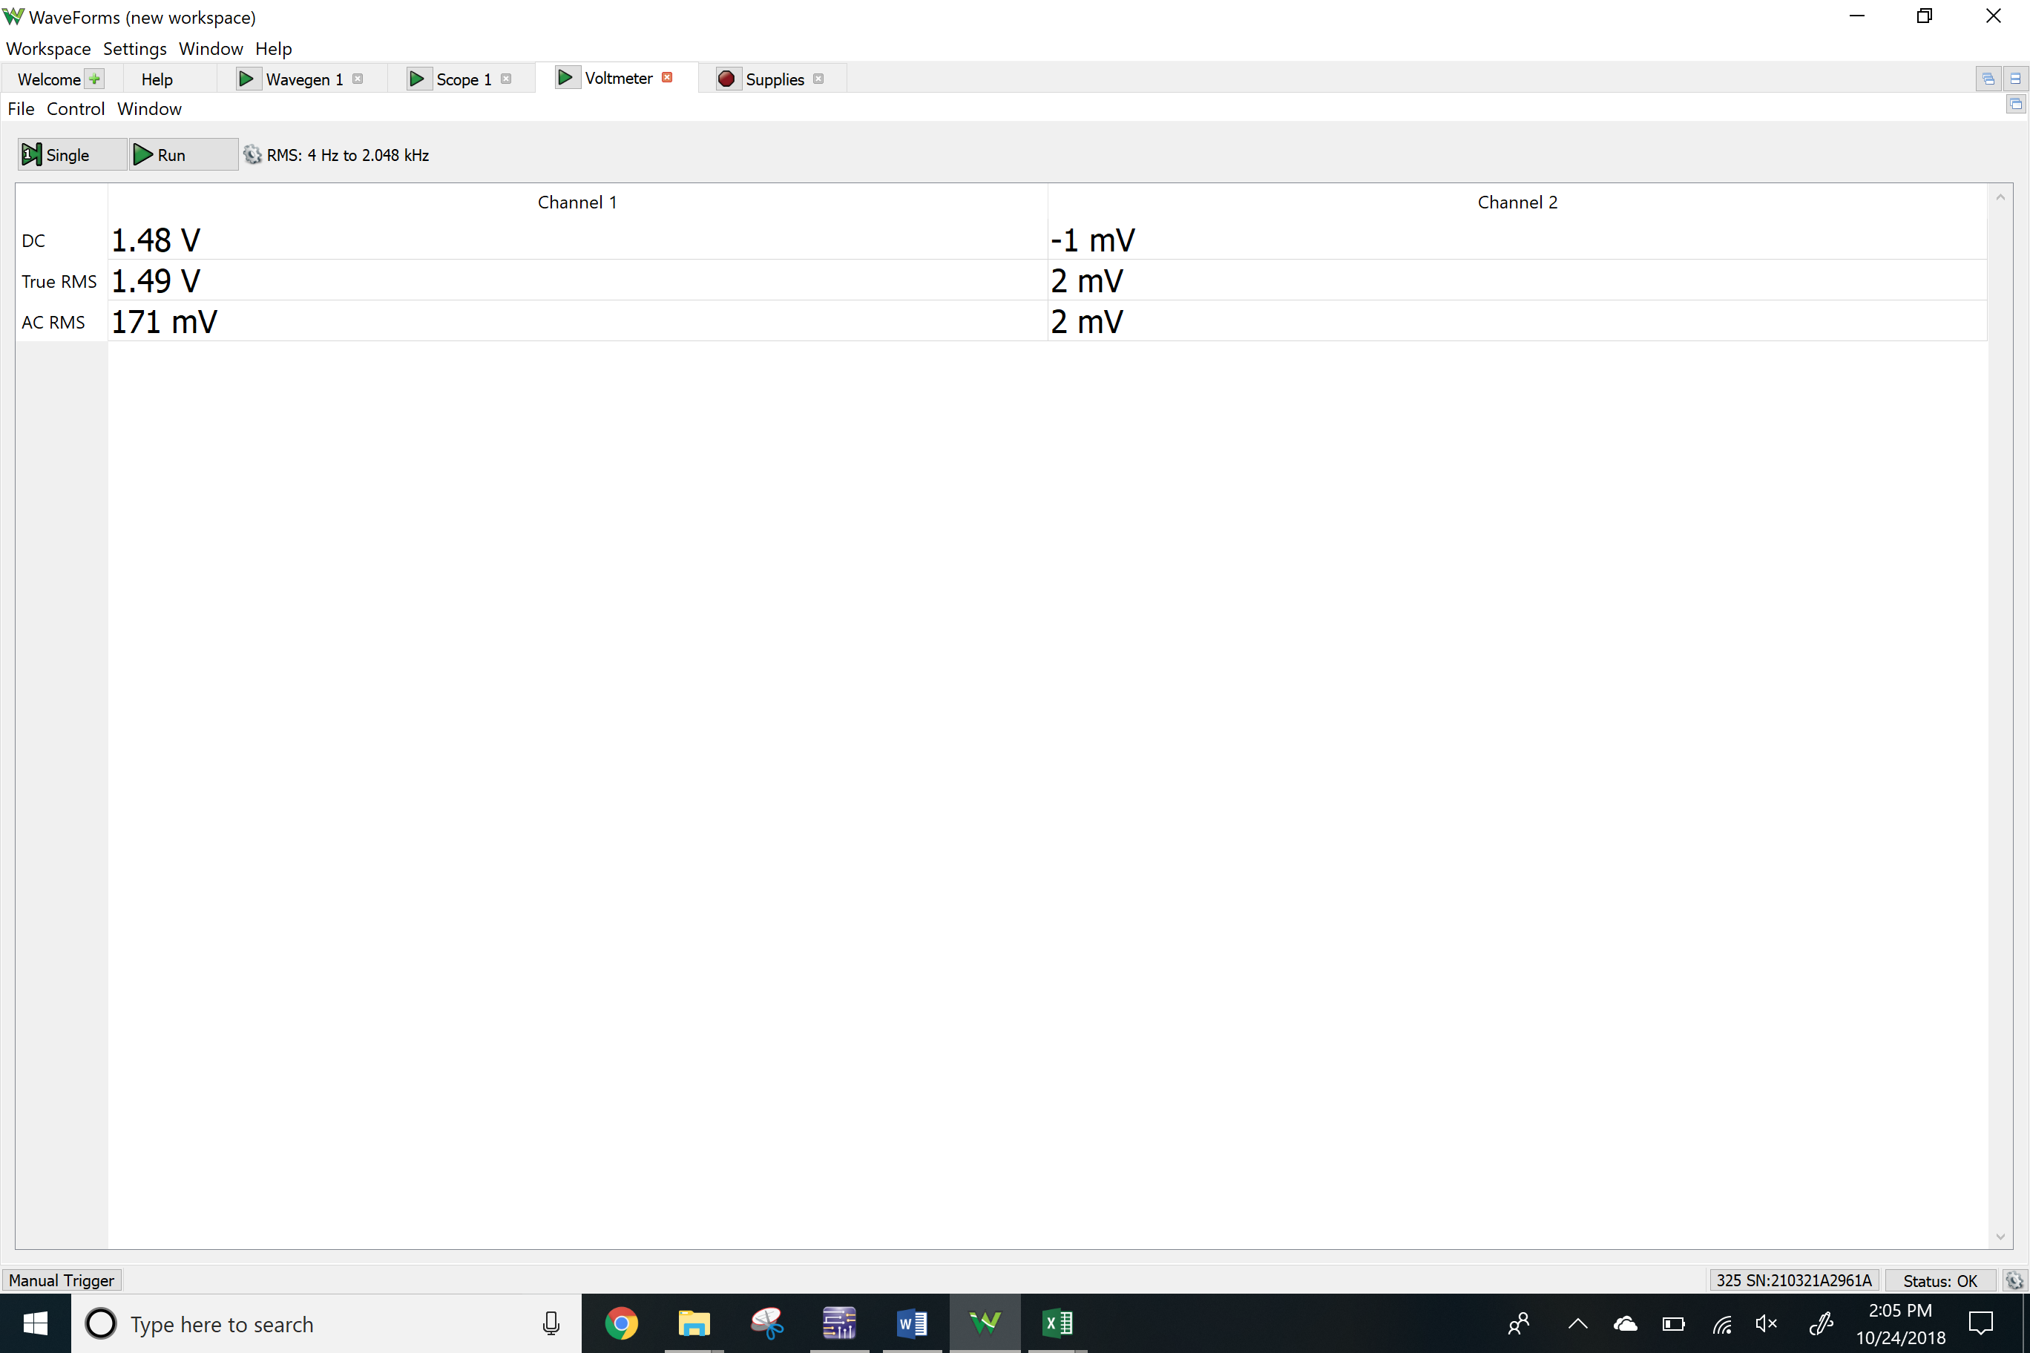

NPN BJT using current source

V2

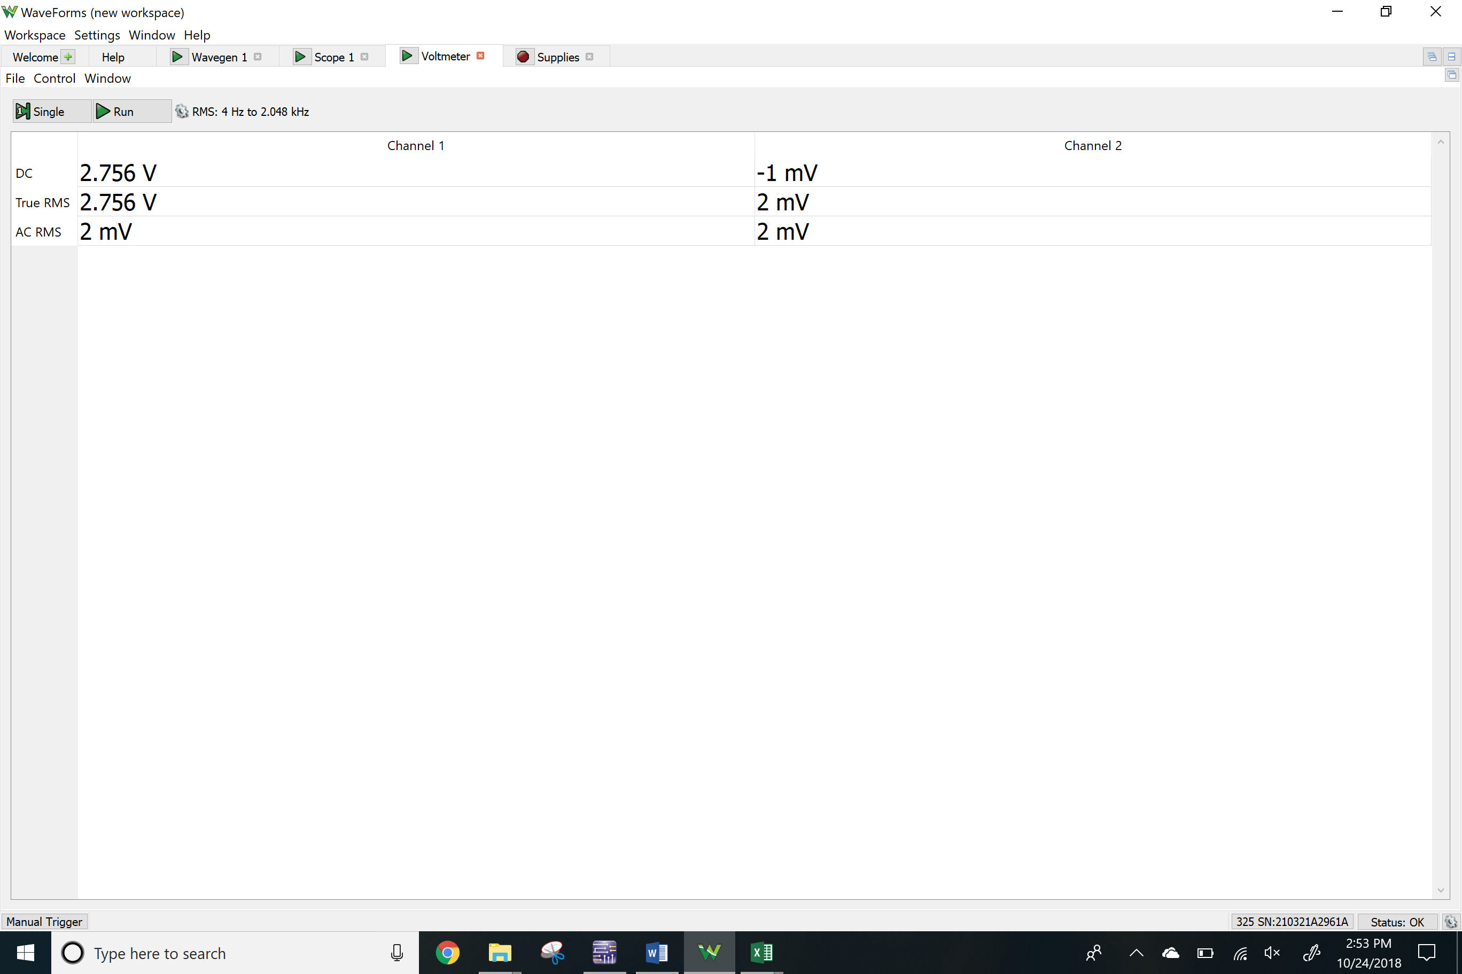Vc

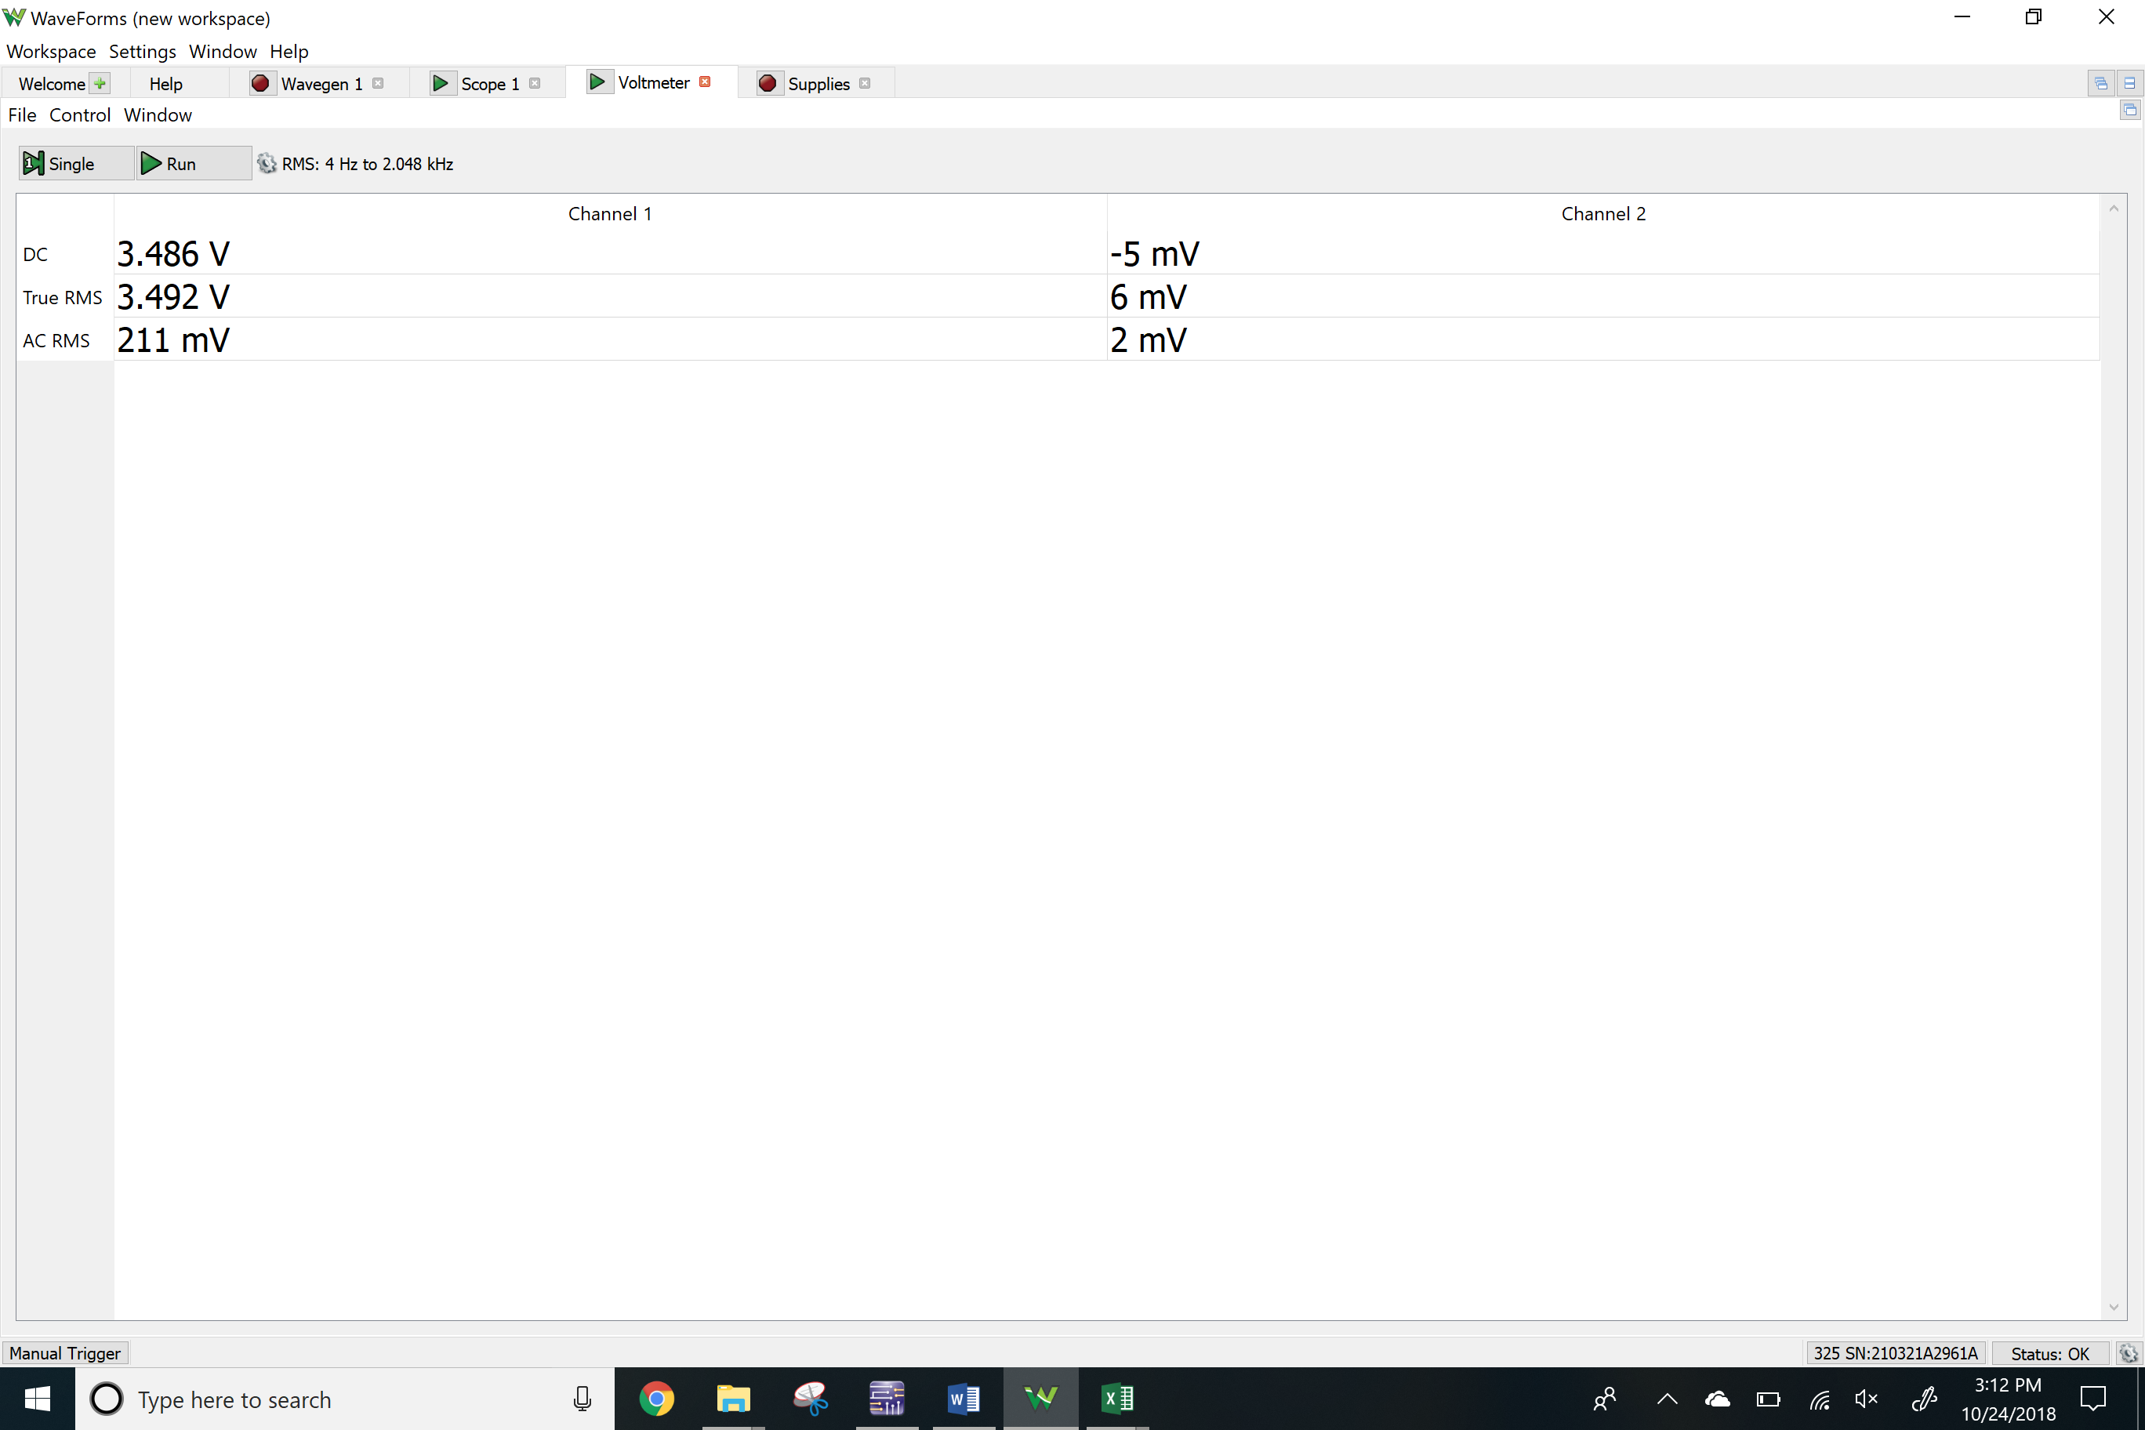

Vx

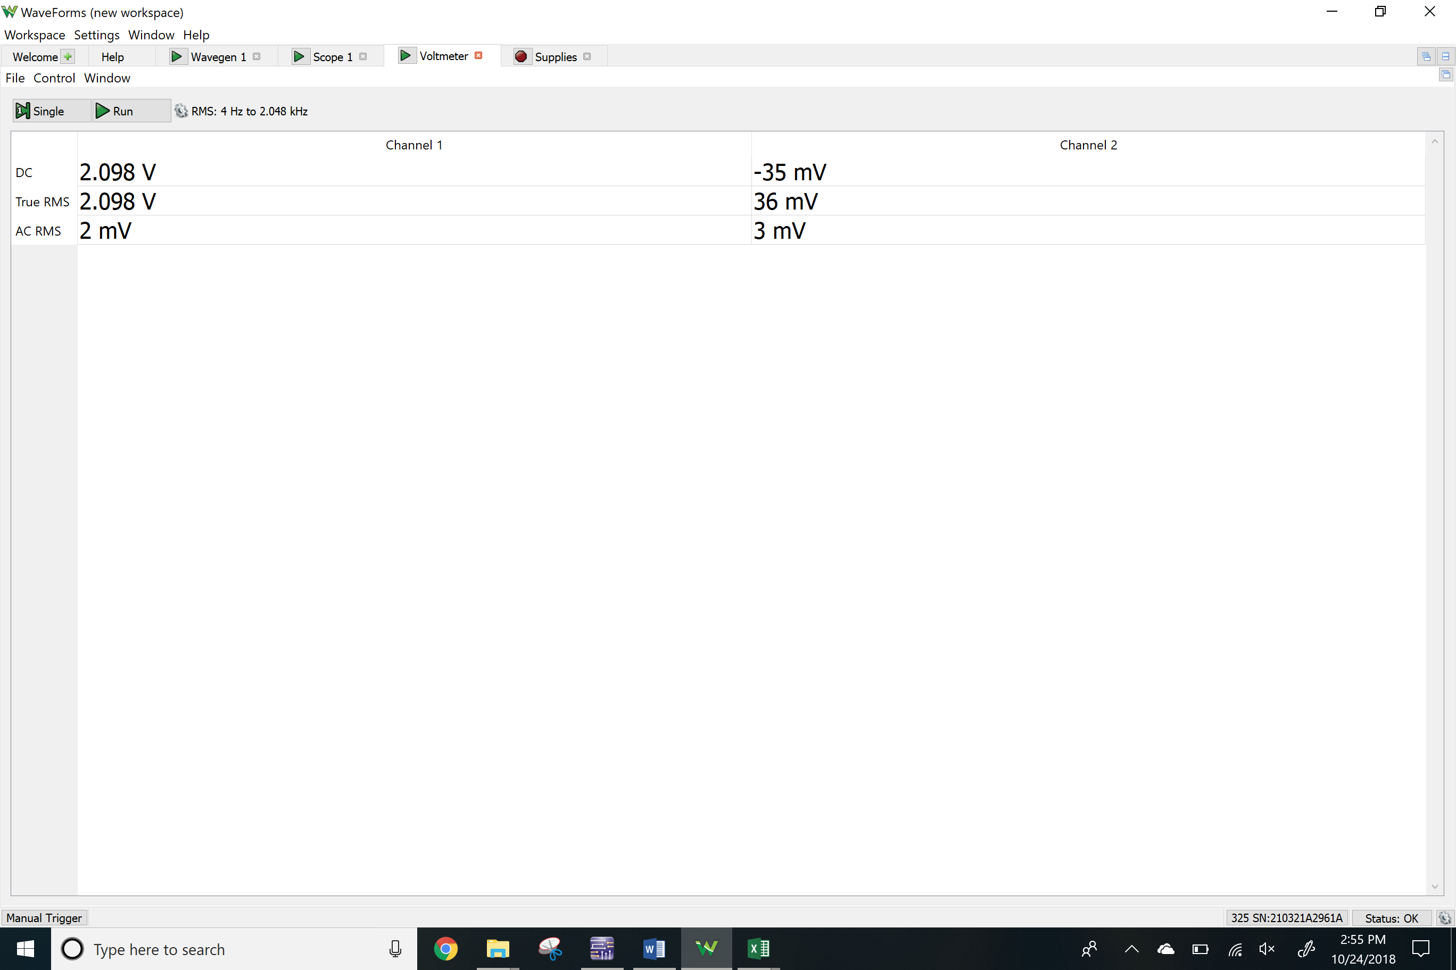

Vy

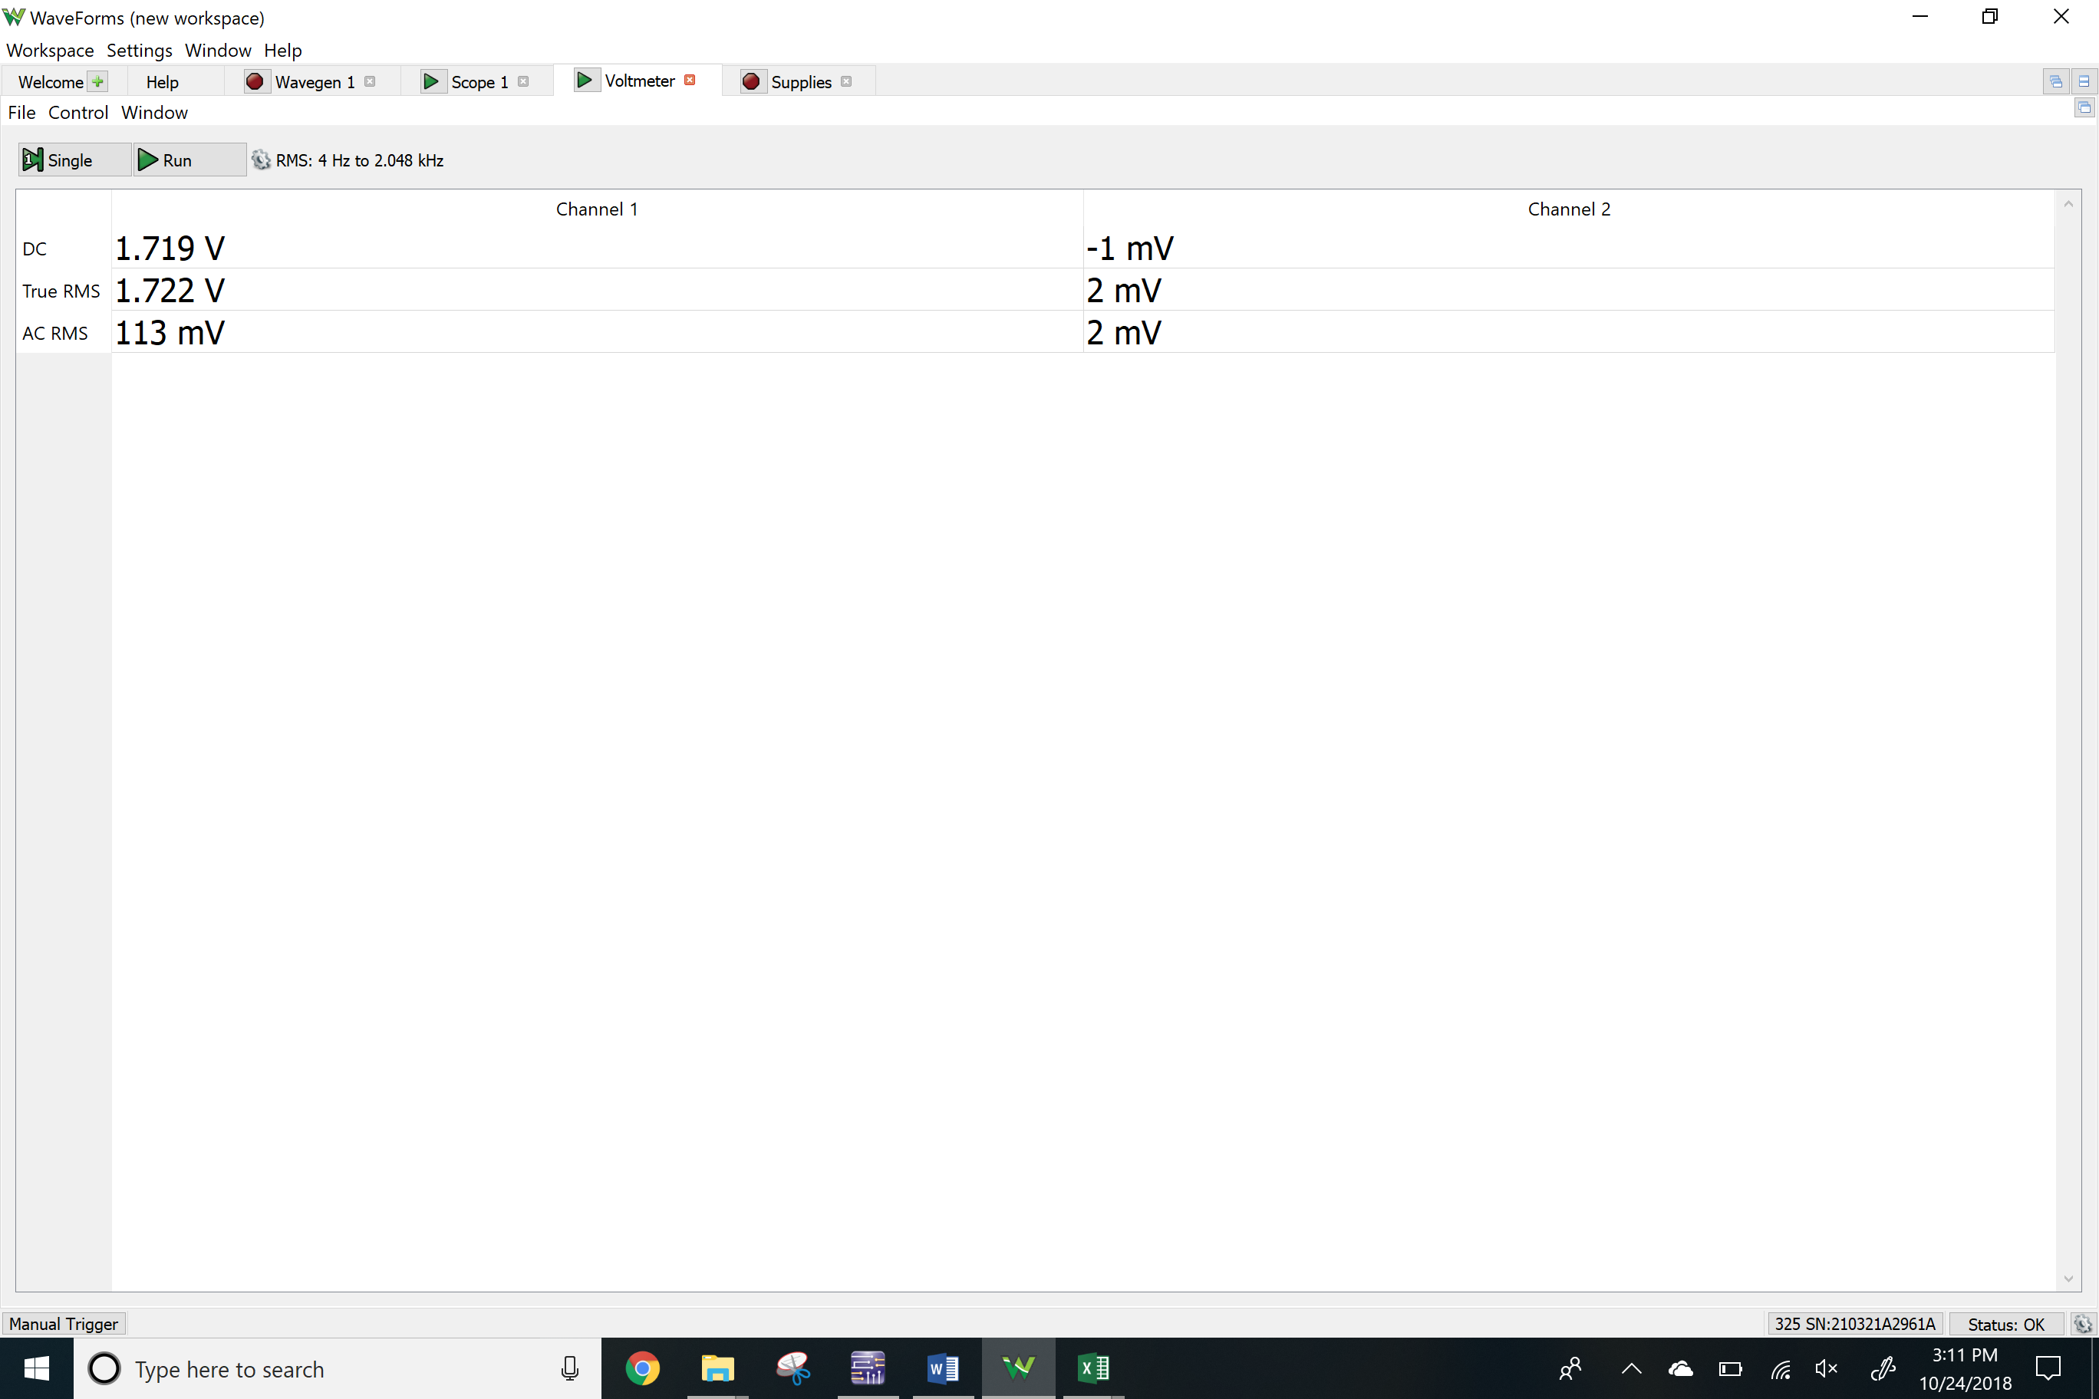

PNP BJT using current source

V2

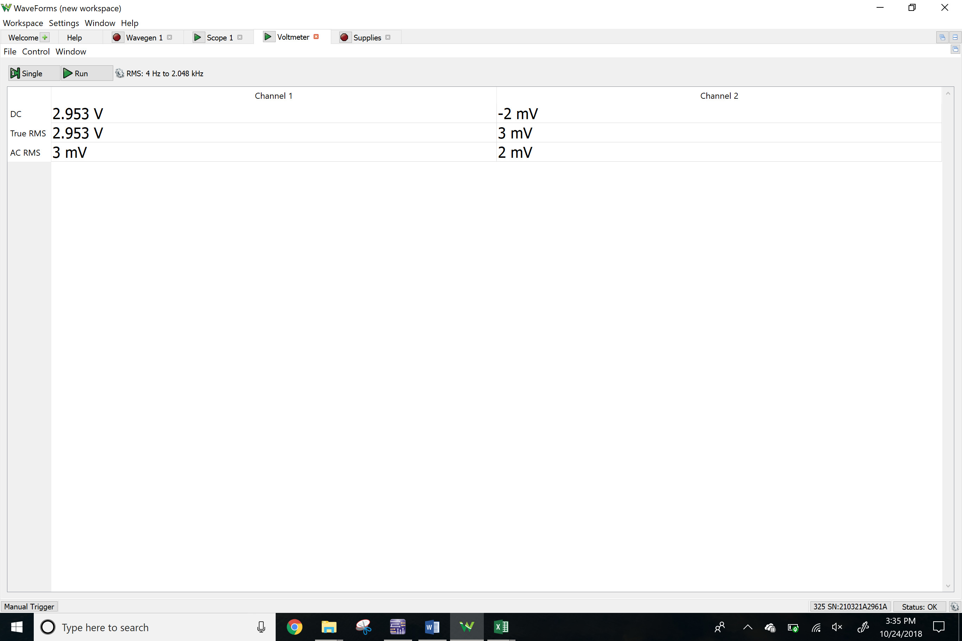

Vc

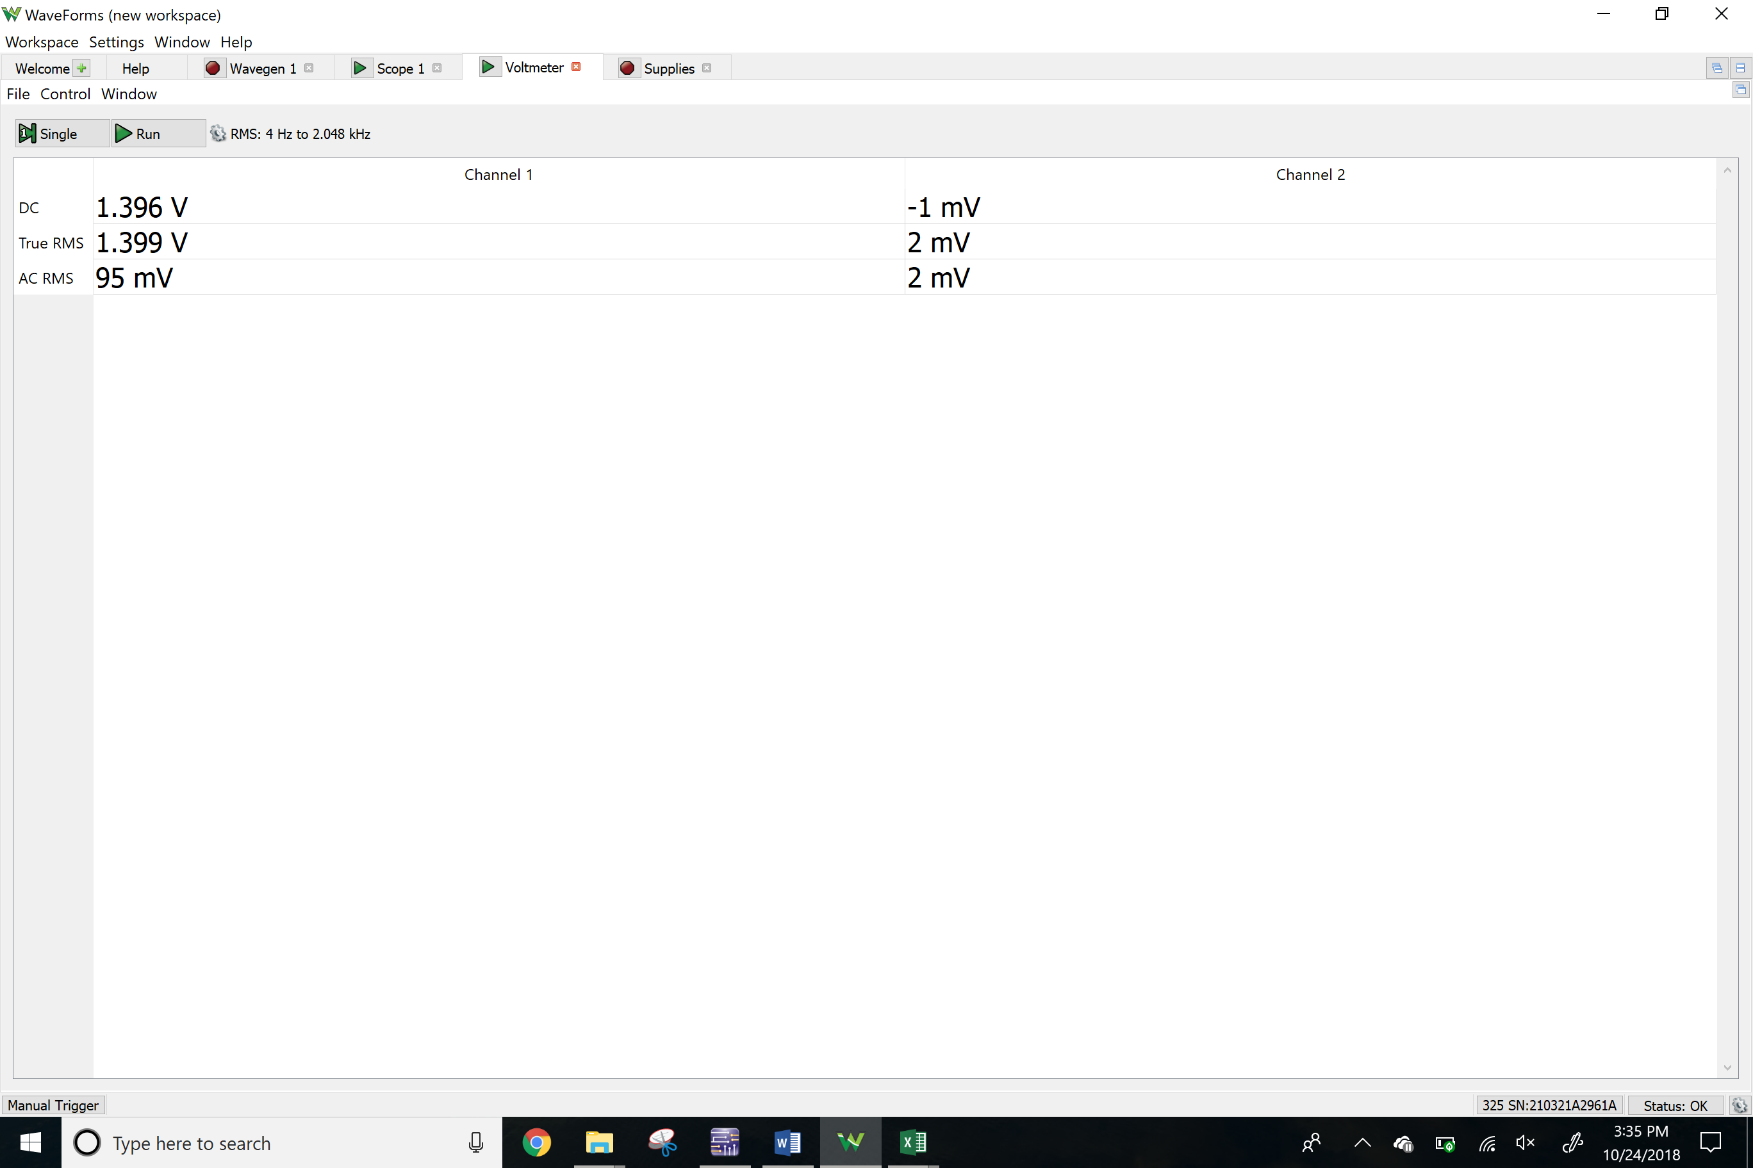Vx

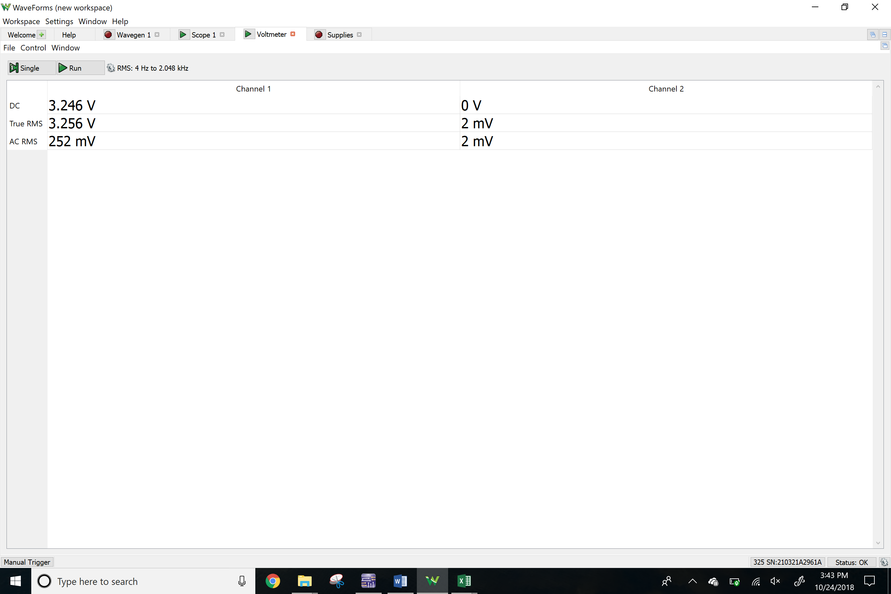

Vy

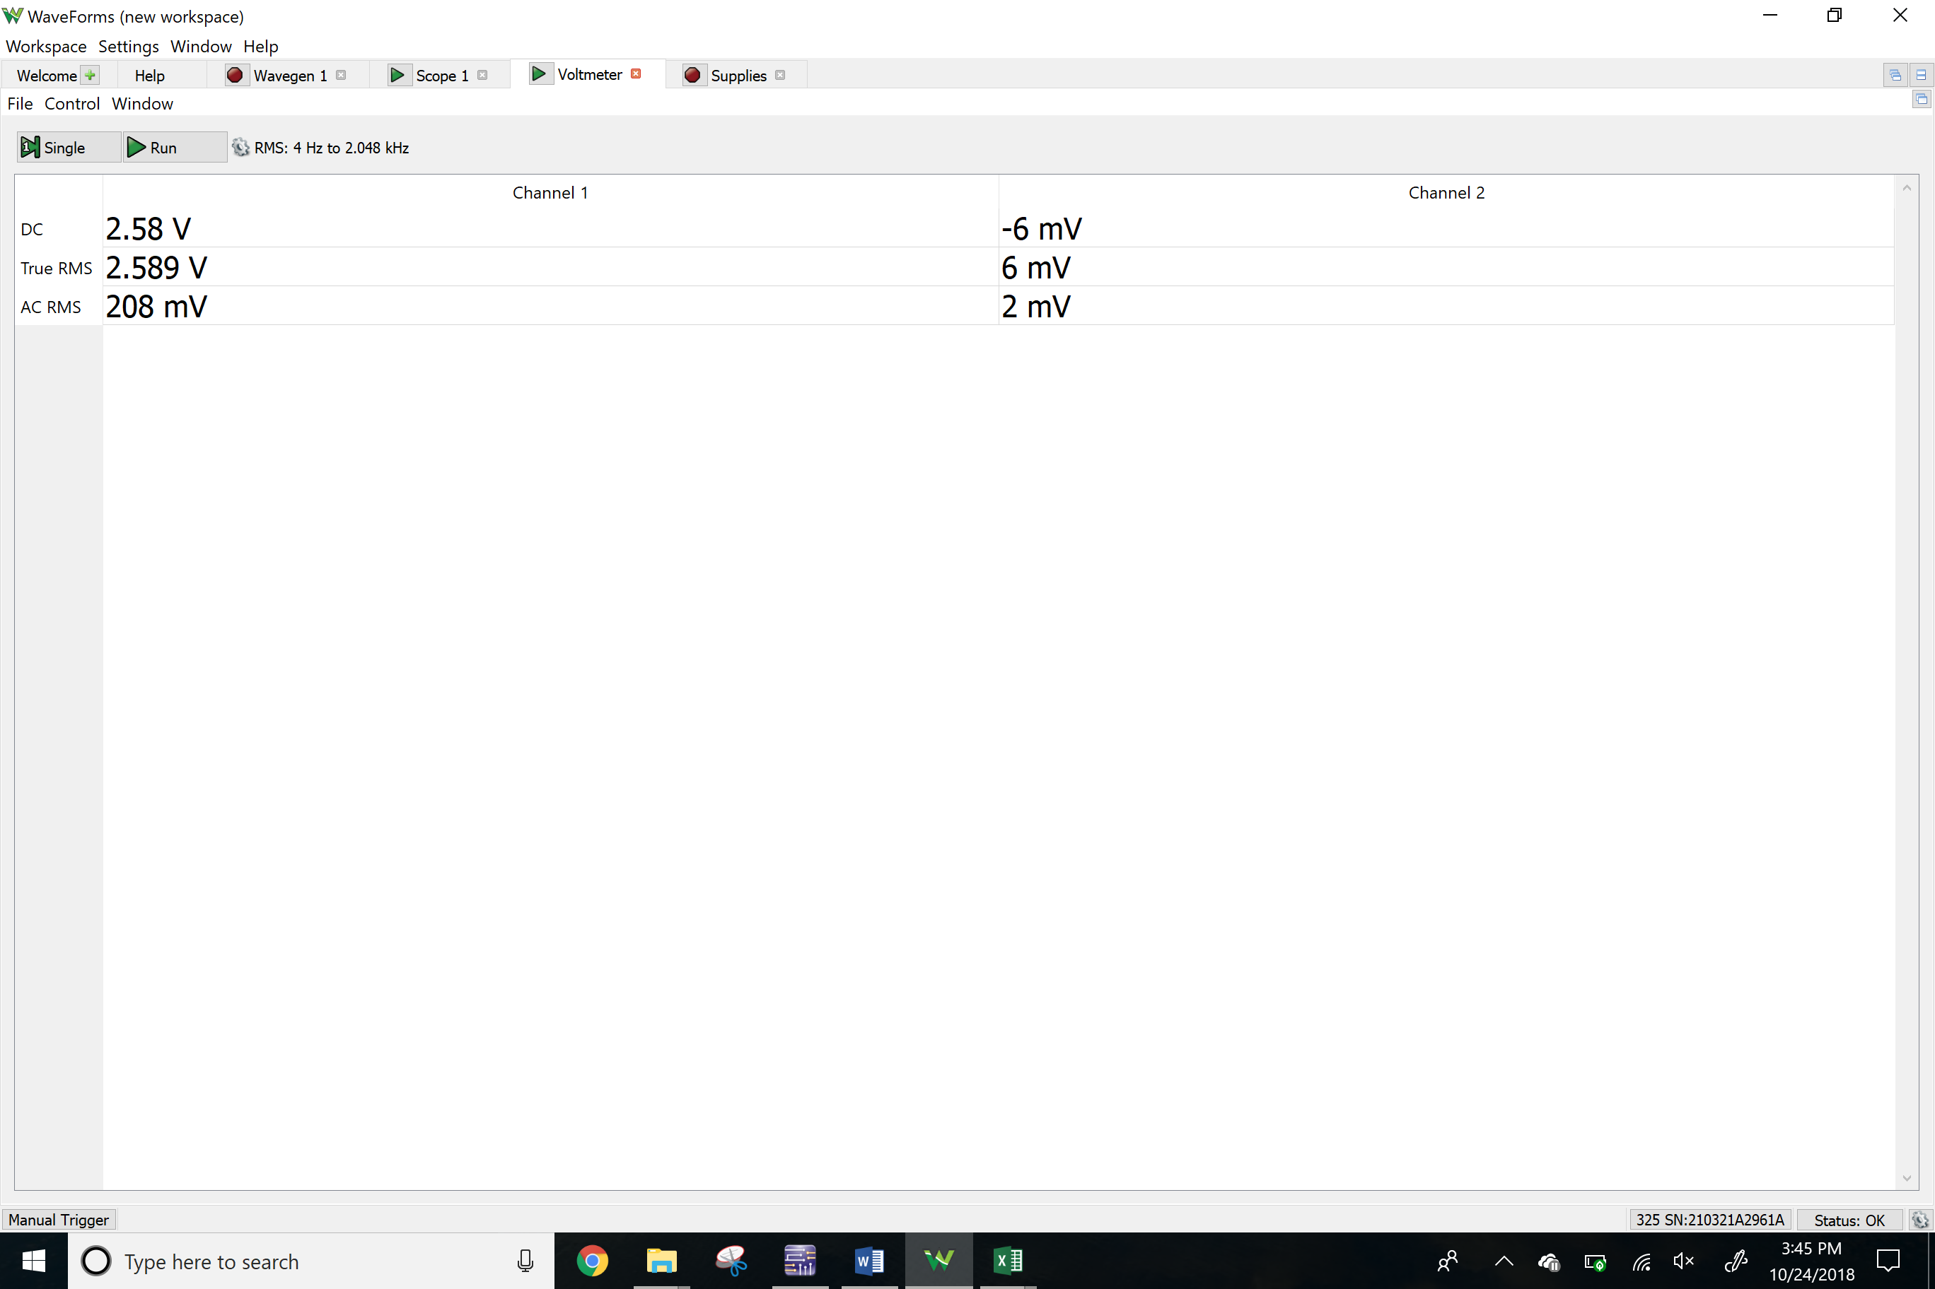

**Results**

Calculated

|  |  |  |  |  |  |  |
| --- | --- | --- | --- | --- | --- | --- |
|  | Rc | Re(R3) | R1 | R2 | Rb1 | Rb2 |
| 6a | 1500 | 2000 | - | - | 2300 | 2700 |
| 6b | 1500 | 2000 | - | - | 2300 | 2700 |
| 7a/b | 750 | 750 | 2500 | 7500 | 2700 | 2300 |
| 8a/b | 750 | 750 | 2500 | 7500 | 2700 | 2300 |

Simulated

|  |  |  |  |  |  |  |
| --- | --- | --- | --- | --- | --- | --- |
|  | V2 | Vre | Vc | Ic | Vx | Vy |
| 6a | 2.6907 V | 2.0250 V | 3.4924 V | 1.005 mA | - | - |
| 6b | 2.6934 V | 3.0112 V | 1.4835 V | 989.03 uA | - | - |
| 7a/b | 2.4950 V | - | 3.5154 V | 1.979 mA | 1.8115 V | 1.9886 V |
| 8a/b | 2.3135 V | - | 1.5086 V | 2.0225 mA | 3.0370 V | 2.6944 V |

Measured

|  |  |  |  |  |  |  |
| --- | --- | --- | --- | --- | --- | --- |
|  | V2 | Vre | Vc | Ic | Vx | Vy |
| 6a | 2.733 V | 2.089 V | 3.407 V | 0.00106 A | - | - |
| 6b | 2.775 V | 2.869 V | 1.48 V | 0.000986 A | - | - |
| 7a/b | 2.756 V | - | 2.098 V | 0.00252 A | 2.098 V | 1.729 V |
| 8a/b | 2.047 V | - | 1.396 V | 0.00232 A | 3.246 V | 2.58 V |

**Conclusion**

The purpose of this lab is to understand the basic concepts of BJT circuits. We have calculated the values of the resistors based on the given paraments. The graph of the input voltage vs the collector voltage is showed to be linear. The graph of the voltage vs the collector current also shows the linear relationship because of the basic control system. The only problem that I have occurred during this lab was to come up close to the values of the resistor calculated.